10 Steps to Take Now
in Light of Estate Tax Legislation

Barry A. Nelson, Esq.

Updated through September 27, 2013

10 Steps to Take Now in Light of Estate Tax Legislation
By: Barry A. Nelson

- Estate & Gift Tax Rates
See Exhibit A for historical rates and Exemptions.
For the year 2013, tax free annual exclusion gifts can be made of $14,000 per person plus additional amounts for health paid to medical care providers and for education paid directly to educational institutions.
Gift and estate taxes are unified such that a single graduated rate schedule and effective exemption amount apply to an individual’s cumulative taxable gifts and benefits. The tax rate reaches 40% at $1 million of taxable transfers. The unified credit is $2,045,800 for 2013 and exempts a total of $5,250,000 of taxable transfers from gift tax or estate tax. The exemption was set at $5 million for 2010 and 2011 and is indexed for inflation. Exhibit E reflects the potential exemption amount based upon projected annual inflation rates of 2.5% and 5% to highlight how significant the exemption indexing is. Married couples each benefit from exemptions so for 2013, $10.5 million can pass free of estate tax to beneficiaries of married couples.
A separate generation skipping transfer tax on transfers to a beneficiary more than one generation below the transferor. For 2013, the GST tax rate is 40% of transfers in excess of $5,250,000.
- Portability
Until 2010, if a husband or wife did not take advantage of their respective unified credit amounts, they were wasted. As a result, planning required the creation of trusts upon the death of the first spouse so that the unified credit amount of the first spouse to die could be allocated into a trust, typically referred to as a Bypass Trust or a Credit Shelter Trust. These trusts allowed the surviving spouse access, but if properly drafted, assets in such trusts were not includible in the gross estate of the surviving spouse. In order to be certain the first spouse to die had sufficient assets to take advantage of his/her unified credit amount, clients were advised they needed to divide assets so both husband and wife had sufficient assets in their own name to take advantage of his or her unified credit amount. Couples were then forced to make decisions on occasion to restructure assets previously held by husband and wife as tenants by the entirety, a title that protects the assets against the claims of only one spouse and avoids probate, and instead, re-title such assets by placing such assets in the husband’s sole name or the wife’s sole name or part in each of their sole names. While this restructuring had potential estate tax benefits, it created asset protection and probate pitfalls. As a result of portability, advisors should review their client’s planning to determine if it is safer to hold assets in an asset protected format that avoids probate (e.g. tenants by the entirety) rather than have their clients hold significant assets in a husband or wife’s sole name.
The analysis is not simple. There are many factors and already much has been written. See Jonathan G. Blattmachr, Austin W. Bramwell, & Diana S.C. Zeydel, Portability or No: The Death of the Credit-Shelter Trust, J. of Tax. (May 2013). Howard M. Zaritsky & Diana S.C. Zeydel, New Portability Temp. Regs. Ease Burden on Small Estates, Offer Planning for Large Ones, J. of Tax. (Oct. 2012). Jonathan G. Blattmachr, Mitchell M. Gans, Howard M. Zaritsky, & Diana S.C. Zeydel, Estate Planning After the 2010 Tax Relief Act: Big Changes, But Still No Certainty, J. of Tax. (Feb. 2011). Howard M. Esterces, Should Portability Make One “Fugeddabout’ Credit Shelter Trusts?, Practical Tax Strategies (Apr. 2011). For those with larger estates (e.g., over $10.5 million), planning with Credit Shelter/Bypass Trusts still provides tax benefits as the assets passing into such trusts upon the death of the first spouse will not be includible in the estate of the surviving spouse regardless of future appreciation. However, for those whose aggregated estates are not likely to exceed $10.5 million plus an inflation factor, it is probably better to have the lifetime benefits of tenants by the entirety ownership for greater asset protection and to reduce potential income tax after both parents pass away by gaining a full step up in basis upon the death of the surviving spouse. The reason is that assets owned (outright but not in a Credit Shelter/Bypass Trust) by the surviving spouse upon death are stepped up to fair market value as of date of death. As a result, if the surviving spouse has an estate of $10.5 million and benefits from portability, then if all assets are sold upon the death of the surviving spouse, no capital gain would be incurred. Instead, if upon the death of the first spouse, assets of $2.5 million were devised to a Credit Shelter/Bypass Trust for the benefit of the surviving spouse and such assets appreciated by $3 million from the death of the first spouse to the death of the surviving spouse, then when the children inherit the Credit Shelter Trust assets, they will only have $2.5 million of income tax basis. As a result, a capital gain of $3 million would be incurred upon the liquidation by the children of assets in the Credit Shelter/Bypass Trust upon the death of the surviving spouse in the example above.
Assuming a 20% capital gains rate, creation of a Credit Shelter/Bypass Trust could result in income taxes of $600,000, in the example above, that would not be incurred if the family relied on portability. Wills should be updated to direct a personal representative to elect portability and an estate tax return needs to be filed upon the death of the first spouse even if the estate is less than $5.25 million, as adjusted.
- Planning for Same Sex Couples in Light of the Defense of Marriage Act (“DOMA”)
The federal estate tax and the Defense of Marriage Act (“DOMA”) collided in a Supreme Court Case, Edith Schlain Windsor v. U. S., 833 F.Supp.2d 394 (S.D.N.Y. 2012), aff’d. 699 F.3d 169 (2nd Cir. Oct. 18, 2012), aff’d. 570 U.S. __ (June 26, 2013).
DOMA was a federal law that required same sex spouses to be treated as unmarried for purposes of federal law, including but not limited to federal tax matters regardless of the recognition of same sex marriage under a number of state laws. The facts in Windsor were that a same sex couple, Windsor and Spyer, lived together in New York for 30 years when they registered as domestic partners in New York City and then married in Canada in 2007. Spyer died in February 2009 and left her estate to Windsor. Because of DOMA, no estate tax marital deduction was allowed and estate taxes of about $363,000 were incurred. Windsor paid the estate tax and brought suit in the Southern District of New York, saying DOMA violated the Equal Protection Clause of the Fifth Amendment. The Federal District Court and the Federal Court of Appeals held in favor of Windsor. The case went to the Supreme Court where a majority of the court held that Section 3 of DOMA was unconstitutional.
For the 13 states that recognize same sex marriage, Windsor results in the couple’s benefiting from federal benefits and exemptions in the same way as a married husband and wife would.
The court in Windsor seemed to go out of its way to not rule on whether states will be required to give any recognition to same sex marriages, or to specify the federal law status of same sex marriages not recognized in the state of domicile. On August 29, 2013, the United States Department of the Treasury and IRS announced that all legal same sex marriages would be recognized for federal tax purposes.
Under Revenue Ruling 2013-17, for federal tax purposes, the terms “husband and wife,” “husband,” and “wife” include an individual married to a person of the same sex if they were lawfully married in a state whose laws authorize the marriage of two individuals of the same sex, and the term “marriage” includes such marriages of individuals of the same sex. As such, for federal tax purposes, the IRS now recognizes the validity of a same sex marriage that was valid in the state where it was entered into, regardless of the married couple’s place of domicile. However, Revenue Ruling 2013-17 also made it clear that for federal tax purposes, the terms “spouse,” “husband and wife,” “husband,” and “wife” do not include individuals (whether of the opposite sex or the same sex) who have entered into a registered domestic partnership, civil union, or other similar formal relationship recognized under state law that is not denominated as a marriage under the laws of that state, and the term “marriage” does not include such formal relationships.
Revenue Ruling 2013-17 and the Windsor decision have no consequence on application of Florida law issues such as tenants by the entirety or a spouse’s homestead rights.
Same sex couples, or a same sex surviving spouse, should consider amending tax returns now or the filing of “protective claims” to avoid any lapse of statute of limitations to take advantage of gift and estate tax marital deductions and joint income tax returns. Failing to file amended returns or claims for refund could result in a statute of limitations bar. Same sex couples should also consider amending their Wills to take advantage of same planning typical couples benefit from.
See Exhibit B for an excellent article entitled “George Karibjanian & Federal Law for Same-Sex Married Couples after Windsor: Equality for All or Only for Some?” published in Steve Leimberg's Estate Planning Email Newsletter - Archive Message #2118 on July 23, 2013.
See Exhibit C for a copy of the August 29, 2013 U.S. Department of the Treasury and IRS joint press release announcing that all legal same sex marriages will be recognized for federal tax purposes, and Exhibit D for Revenue Ruling 2013-17 (same sex marriages recognized for federal income tax purposes).
- Review of Existing Estate Plans to Avoid Surprises of Excess Gifts as a Result of Increased Unified Credit
See Exhibit E for the projected unified credit amount increases.
When the unified credit was $1 million and increased to $3.5 million in 2009, some very wealthy couples decided they could afford to leave the unified credit amount to their children and/or grandchildren upon the death of the first spouse to die. This planning typically was based upon the assumption that funds remaining after the gift to children/grandchildren would be sufficient for the surviving spouse. However, in 2010 when the unified credit amount increased to $5 million indexed by inflation, the gift by a formula in an older Will of the maximum amount that can pass free of estate tax could result in the children/grandchildren receiving too much and the surviving spouse too little. Without review of Wills and Trusts while the spouses are living, adverse consequences to the surviving spouse and family relatives are likely.
- Planning Opportunities That Could Be Gone Soon. Loopholes Closed
For years a number of tax savings techniques have been on a “Loophole List” which could result in legislation taking away these techniques. It is possible some loopholes may be closed. Typically, loopholes are closed prospectively. Some of the techniques that could no longer be available are: (i) short term Grantor Retained Annuity Trusts (“GRATs”) (See Exhibit F); (ii) sales to Intentionally Defective Grantor Trusts; (iii) discounting gifts using limited liability companies (LLC)s, limited partnerships, and gifts of undivided fractional ownership; and (iv) use of Dynasty Trusts.
As a result of inflation, the unified credit increased from $5,120,000 in 2012 to $5,250,000 in 2013. Thus, every client who previously used his or her unified credit amount in full prior to 2013 still have the ability to initiate additional 2013 gifting of at least $130,000 before the loopholes are closed. The benefits of making use of all or a portion of the $5.25 million unified credit amount by gift to shift appreciation are illustrated in Exhibit G.
- Make Use of Low Interest Rate
We have been benefitting for many years from low interest rates that allow parents to make low interest loans to their family members. Interest rates have already begun to increase. See Exhibit H for the 7520 rates over prior years to reflect interest rate trends and why it is most likely a good time for intra family loans or installment sales. Consider simple planning with intra family loans, see Exhibit I. Note interest rates have increased about .7% on mid and long term rates from July 2013 until October 2013.
- Examine Existing Partnership Structures to Determine if Costs Still Warrant Tax Benefits
Many clients initiated partnerships, discounts, and other more complex planning when exemptions were significantly less than $5,250,000 ($10.5 million for couples). Some have done an excellent job administering their planning documents. Others have not respected the formalities. Now is the time to review. If the client is not likely to be subject to estate tax in light of existing exemptions and projected increases, then it may be time to consider how to unravel for simplicity, administrative savings, and possibly even future income tax savings.
- Review Credit Shelter Trusts To See If Generous Discretionary Distributions Should Be Made To Spouse
As noted above, assets in a Credit Shelter Trust/Bypass Trust do not benefit from a step up in income tax basis. Therefore, when children inherit appreciated assets from such a trust upon death of a spouse, the beneficiaries will be subject to income taxes that possibly would have been avoided if the trust assets were includible in the surviving spouse’s estate since, in such event, income tax basis would be stepped up to date of death value. Accordingly, if the Trustee distributes assets to the surviving spouse under a broad power, and assuming such outright distributions to the surviving spouse will not result in increasing her estate to $5,250,000, such transfers would result in no additional estate tax and reduced income tax. Many issues need evaluation such as whether the beneficiaries of the surviving spouse are the same in his/her Will as in the Credit Shelter/Bypass Trust, whether there are concerns about creditors, and whether the surviving spouse may be subject to end of life manipulation. If the facts are favorable, the tax benefit may be material.
- Modifying Estate Plans to Protect Gifts to Beneficiaries
See Exhibit J.
- Use of Inter Vivos QTIP Trusts to Maximize Asset Protection for Families with Net Worth of $10.5 Million (+/-)
See Exhibit K.

Exhibits

EXHIBIT A Estate, Gift and GST Tax Rates and Exemptions
EXHIBIT B Steve Leimberg's Estate Planning Email Newsletter - Archive Message #2118
EXHIBIT C IRS Ruling IR-2013-72, Aug. 29, 2013
EXHIBIT D Rev. Rul. 2013-17
EXHIBIT E Projected Unified Credit Increases
EXHIBIT F GRAT
EXHIBIT G Advantage of Lifetime Gift of Unified Credit to Shift Future Appreciation
EXHIBIT H 7520 Interest Rates & AFRs
EXHIBIT I Intra-Family Loans and AFRs
EXHIBIT J Are Trust Funds Safe From Claims for Alimony or Child Support?
EXHIBIT K New §736.0505(3) Assures Tax/Asset Protection
of Inter Vivos QTIP Trusts

Estate, Gift and GST Tax Rates and Exemptions

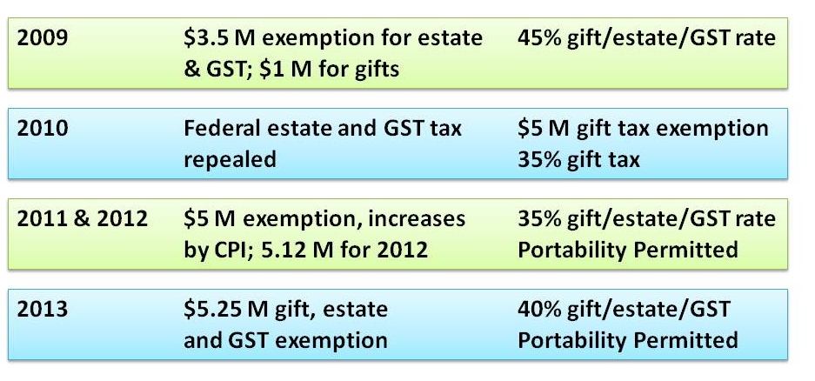

Steve Leimberg's Estate Planning Email Newsletter - Archive Message #2118
Published on 7/23/13

Steve Leimberg's Estate Planning Email Newsletter - Archive Message #2118

Date: | 23-Jul-13
From: | Steve Leimberg's Estate Planning Newsletter
Subject: | George Karibjanian & Federal Law for Same-Sex Married Couples after Windsor: Equality for All or Only for Some?

“The consequences of the unconstitutionality ruling in Windsor are complex and require a thorough analysis by Congress or the Service with respect to determining the effect of the decision on same-sex married couples in Non-Recognition States. While there is ample support for granting or denying federal benefits to such couples, the better legal support rests with the granting of such benefits. Whenever such guidance is issued, it should consider as many issues and variables as possible so that the guidance is forceful and complete.”
In Estate Planning Newsletter #2110, George Karibjanian provided LISI members with detailed commentary on the Windsor opinion. In his latest commentary, George explores the “recognition” issues raised by the decision, and also proposes an outcome he believes the federal government should adopt.
George D. Karibjanian is a Senior Counsel in the Personal Planning Department of Proskauer Rose LLP and practices in Proskauer's Boca Raton office. George a Fellow in the American College of Trust and Estate Counsel and is Board Certified by the Florida Bar in Wills, Trusts and Estates and earned his B.B.A. in Accounting from the University of Notre Dame in 1984, his J.D. from Villanova University in 1987 and his LL.M. in Taxation from the University of Florida in 1988. George lectures and writes extensively on various estate planning issues and has recently written several articles for LISI on the topic of same-sex estate planning. This Article is based on materials to be presented by the author at upcoming lectures on the effect of the recent Supreme Court decisions on federal rights for same-sex married couples.
Here is his commentary:
EXECUTIVE SUMMARY:
The June 26, 2013 decision of the United States Supreme Court in Windsor v. United States[1] determined that §3 of 1996's "Defense of Marriage Act," which defined marriage as between "one man and one woman," is unconstitutional and also held that the concept of defining "marriage" is the exclusive domain of the states. Since that date, much has been discussed as to whether federal rights associated with marriage will be applied to all same-sex married couples. This commentary will explore the recognition issues and propose the outcome that the author believes that the federal government should adopt.
FACTS:
For those married couples who live in "Recognition States," or those states that have approved same-sex marriage through specific legislation, voter referendum or judicial decree, the effect of the Windsor decision is that same-sex married couples now enjoy all of the federal and state benefits that their opposite-sex married brethren enjoy. In the planning arena, such benefits include, but are not limited to, filing joint income tax returns; the unlimited marital deduction for gift and estate tax purposes; naming the spouse as the beneficiary under a qualified retirement account and allowing the “roll over” the account into his or her own account, thereby potentially extending the ultimate payout of the account; electing portability of the deceased spouse’s unused applicable exclusion amount; simplifying the basis and contribution rules with respect to jointly owned property; splitting of inter-vivos gifts; eliminating adverse tax consequences for the transfer of property pursuant to a marriage settlement agreement; and granting certain social security, Medicare and Medicaid benefits.
Certain states have prohibited same-sex marriages and some expand the prohibition to specifically not recognize a valid same-sex marriage from another jurisdiction (i.e., “Non-Recognition States”). An example of provisions contained in Non-Recognition States is found in Florida, which has both a constitutional and statutory prohibition:
Section 27 to the Florida Constitution: “Inasmuch as marriage is the legal union of only one man and one woman as husband and wife, no other legal union that is treated as marriage or the substantial equivalent thereof shall be valid or recognized.” (emphasis added.)
Florida Statutes § 741.212(1): “Marriages between persons of the same sex entered into in any jurisdiction, whether within or outside the State of Florida, the United States, or any other jurisdiction, either domestic or foreign, or any other place or location, or relationships between persons of the same sex which are treated as marriages in any jurisdiction, whether within or outside the State of Florida, the United States, or any other jurisdiction, either domestic or foreign, or any other place or location, are not recognized for any purpose in this state. (emphasis added.)
For those same-sex married couples who reside in Non-Recognition States, the effect of the Windsor opinion has led to considerable intellectual debate as to whether such couples should be afforded federal benefits attributed to married opposite-sex persons.
COMMENT:
Next Saturday Night’s Blockbuster Pay-Per-View Fight: “State of Ceremony vs. State of Residence - The Fight for Federal Recognition”[2]
Part of the post-Windsor confusion surrounds the terminology used in the opinion itself. The majority opinion in Windsor consistently refers to the recognition of the marriage by the “State.” Query as to which state is referenced - the state of ceremony of the marriage (the “State of Ceremony”) or the state of residence of the couple (the “State of Residence”)? This question was not lost on Justice Scalia in his dissent as he framed this open issue as part of his argument on the lack of clarity and forethought of the majority's opinion.[3]
State of Residence is Tantamount to Federal Recognition - Benefits Are Only Afforded to Couples Residing in the State of Ceremony
Many post-decision comments have discussed the effect of Windsor as if the federal application is limited only to those couples residing in the State of Ceremony. Presumably, this can be read into the Windsor opinion considering that the opinion is focused on the effect of DOMA as to applicable “State” law. For example, the Windsor opinion states that, “[t]he recognition of civil marriages is central to state domestic relations law applicable to its residents and citizens. See Williams v. North Carolina, 317 U. S. 287, 298 (1942) (“Each state as a sovereign has a rightful and legitimate concern in the marital status of persons domiciled within its borders”).”[4] In addition, by the time of this decision, Mrs. Windsor and Mrs. Spyer’s home state – New York – had passed same-sex marriage laws, so it would appear that the majority opinion was focused on cases where the same-sex married couple was residing in a Recognition State.
The following sets forth the argument limiting recognition to the State of Ceremony.[5] Unless and until the Supreme Court holds that same-sex marriage is a fundamental federal constitutional right, it is solely within the province of each sovereign state to determine the validity of such marriages for all purposes within its jurisdiction and that authority is not limited or restricted in any way by the Full Faith and Credit clause of Article IV of the U.S. Constitution. Under Windsor, federal statutes or regulations cannot treat a person as unmarried for federal purposes when the jurisdiction that controls their marital status says that they are legally married; conversely, federal statutes or regulations cannot treat a person as married when the jurisdiction that controls their marital status, i.e., the State of Residence, states that they are not married. In each case, there must be one state whose laws apply, and that state can only be the State of Residence; the alternative is to allow the taxpayer and/or the federal government to pick and choose the state law that they would like to apply, which cannot be the law and it finds no support in Windsor.
This fundamental state-determined marital status concept seems quite analogous to the state-determined rules of property. There is no federal property law and the federal government looks to the law of the state to determine who owns what property interests, and it is not uncommon for federal tax consequences to be affected by state property law.
Therefore, if certain tax benefits such as the marital deduction and joint filing status (the “Federal Benefits”) are based upon marital status, and since the states are the final arbiter of marital status, then the conclusion seems inescapable that marital status for purposes of receiving Federal Benefits is going to be determined by the State of Residence. If the State of Residence is a Non-Recognition State, the federal government cannot recognize the couple as being married and cannot afford them any Federal Benefits because their state would not recognize the marriage. This would be ironic because Windsor is commonly viewed as a liberal victory but, after full and objective scrutiny, may ultimately be a very conservative approach that may cause large numbers of same-sex couples to migrate and establish residency in the dozen or so states that recognize same-sex marriage in order to obtain the Federal Benefits.
Laws of the “State of Residency” Are Irrelevant - Married is Married is Married for Purposes of Receiving Federal Benefits
Other post-decision commenters have advocated that the State of Residence is irrelevant. If a same-sex couple is legally married, the marriage legally exists notwithstanding the recognition laws of the State of Residence, so the federal government must afford the couple all of the Federal Benefits of marriage.
The framework for stating that the State of Residency is irrelevant is laid out as follows. The distinction worth noting is that Non-Recognition States do not “invalidate” the marriage but rather do not “recognize” the marriage; thus, a same-sex married couple who moves to a Non-Recognition State is still legally married even though the State of Residence does not recognize the marriage. With respect to the property rights analogy, because the same-sex married couple residing in the Non-Recognition State remains legally married in jurisdictions that recognize same-sex marriages, the couple conceivably could continue to reside in the Non-Recognition State and purchase real property in a Recognition State that also recognizes tenancy-by-the-entireties (which requires the parties to be married to each other) (“TBE”). If such property it titled as TBE, the couple should receive all of the benefits of TBE.
Therefore, since the Windsor opinion stands for the proposition that the federal government cannot purport to define marriage because this is the exclusive province of the states, it stands to reason that if the parties are still legally married, and if the federal government attempted to restrict the applicability of federal law to only those same-sex married individuals who are residing in the State of Ceremony, this is technically a federal definition of marriage which, according to the Windsor opinion, is impermissible.
So Which Argument is the Correct Argument?
Until Congress or the Internal Revenue Service (the “Service”) issues guidance, there is no definitive correct interpretation.[6]. However, the author believes that the better interpretation would be that the State of Residency is irrelevant for federal purposes.
Consider the case of an opposite-sex couple who marries in New York and then moves to Florida. Three years after the move, the couple decides to divorce, so a judgment is rendered in the Florida courts terminating the marriage that originated in New York. It is clear that New York will acknowledge the divorce of its marriage by the Florida court.
Now suppose that the couple is a same-sex couple who marries in New York and moves to Florida. If the argument is made that a “non-recognition” statute holds the marriage as invalid, does this technically terminate the marriage, and, if so, if the couple later returns to New York, are they still married? If the “non-recognition” statute terminates the marriage, then no, they would not be married upon returning to New York; however, it is highly unlikely that a New York court would respect this absent some form of decree or court order terminating the marriage. Thus, unless marriage itself is a “springing” concept, i.e., dormant under Florida law and then “revived” upon return to New York, the parties likely remain married during the period of non-recognition in Florida. If the parties are still married, then seemingly any limitation on the classification of “marriage” would be a violation of Windsor.
Is the Answer Within the Facts of Windsor?
In 2006, in Hernandez v. Robles,[7] the New York Court of Appeals affirmed that New York’s Domestic Relations Laws, whether implicitly or explicitly,[8] prohibited same-sex marriage and that such laws were supported by rational basis; did not violate due process, and did not violate equal protection. Since Mrs. Spyer died in 2009 and New York’s recognition of same-sex marriage was adopted in 2011, at the time of Mrs. Spyer’s death New York did not recognize same-sex marriage. Since the Southern District of New York stated that Mrs. Spyer’s estate was entitled to the marital deduction, and noting that Mrs. Spyer and Mrs. Windsor were married in Canada, query whether the Southern District was stating that the marital deduction was not limited to only same-sex married couples residing in the State of Ceremony.
While this interpretation can be made, one fact distinguishes the Windsor/Spyer marriage from the example of a same-sex couple residing in Florida – at the time of Mrs. Spyer’s death, New York was not a Non-Recognition State. In February 2008, the Supreme Court, Appellate Division, Fourth Department ruled unanimously in Martinez v. County of Monroe[9] that because New York legally recognizes out-of-state marriages of opposite-sex couples, it must do the same for same-sex couples. Thus, unconstitutionality notwithstanding, it is not known whether the Southern District would have allowed the marital deduction if New York were a Non-Recognition State.
Rev. Rul. 58-66 - Can this be Applied by Analogy?
Perhaps guidance can be found in a 1958 Revenue Ruling concerning common law marriages. The issue for determination by the Service in Rev. Rul. 58-66[10] was whether a common law married couple was considered to be married for federal purposes upon their move to a state that required a marriage ceremony for marriages within such state. The Service determined that the marital status of individuals as determined under state law is recognized in the administration of federal income tax laws. If applicable state law recognizes common-law marriages, the status of individuals living in such relationship that the state that creates the marital relationship would also apply for federal income tax purposes so that for all such purposes, they would be husband and wife. The Service also stated that if the couple subsequently moves to a state where a ceremony is required (i.e., common law marriages are not valid), it is irrelevant in that the couple will still be considered to be spouses pursuant to federal law.
If this ruling is applied to the same-sex marriage discussion, the State of Residency is irrelevant – so long as they are legally married in the state that recognizes the marriage, they are married for all federal purposes regardless if they move from such state to a Non-Recognition State.
However, proponents of the “State of Ceremony” argument can counter this argument with provisions from the federal regulations pertaining to social security and other federal retirement benefits. For example, in the regulations pertaining to Public Safety Officers' Death, Disability, and Educational Assistance Benefit Claims, in the definitional section, the term “spouse” includes as part of its definition, “[f]or an individual purporting to be a spouse on the basis of a common-law marriage (or a putative marriage) to be considered a spouse within the meaning of this definition, it is necessary (but not sufficient) for the jurisdiction of domicile of the parties to recognize such individual as the lawful spouse of the other…” (emphasis added.)[11]
Another regulation in the same retirement benefit area concerns the Railroad Retirement Board and the determination of the marriage relationship. In these regulations, the definition of the “marital relationship” includes common-law marriages that are recognized under applicable State law.[12] Thus, the counterargument provides that other areas of federal law focus on the laws of the state of residency for recognition before awarding federal benefits.[13]
While it could be argued that the Service could follow the precedent of Rev. Rul. 58-66 and continue the apparent division of treatment of common law marriages under federal law, query whether, as a result of the Windsor opinion, there is justification for such division. Seemingly the same questions may be asked of common law marriages as are asked about same-sex marriages.
Note that if it is subsequently determined that Windsor stands for the proposition that the State of Residence is irrelevant for federal benefits, this is seemingly an affirmation that no classification distinctions are permissible under federal law. If so, query whether the cited federal retirement regulations would be deemed invalid in that if a common law marriage is valid at the inception, it should be valid regardless of where the parties reside.
Nevertheless, the existence of the marriage “recognition” requirement under the federal retirement regulations is a sound counter-argument to the absolute application of Rev. Rul. 58-66.
Subsequent Federal Governmental Actions May Indicate Irrelevancy of State of Residence
In the days that followed the Windsor opinion, two separate federal actions may have "tipped the hand" of the federal government's potential response to this question.
On June 28, 2013, Elaine Kaplan, the Acting Director of the United States Office of Personnel Management, released a memorandum (the “Memorandum”) regarding eligibility for federal benefits for same-sex married couples and their families regarding health insurance, life insurance, dental and vision insurance, long-term care insurance, retirement and flexible spending accounts. The Memorandum fails to require residency in either the State of Ceremony or another state that recognizes same-sex marriages for the couple to complete the requisite forms to receive such benefits.
The second federal action also occurred on June 28, 2013, when an immigration “green card” was issued to the foreign spouse of a United States citizen, thus allowing the spouse to remain in the United States.[14] The couple’s counsel noted that though such petitions have been previously rejected, the couple's green card petition was approved following the Windsor decision. Noting that Florida is a Non-Recognition State, if residency in the State of Ceremony or another state recognizing same-sex marriage were an important element to federal classification as “married,” it is highly likely that said green card would not have been issued.
Even if State of Residence is Irrelevant - What About “Forum Shopping Marriages”?
Assume that the State of Residence is irrelevant as to the determination of federal benefits - is there any distinction between a same-sex couple legally married in a Recognition State who then move to a Non-Recognition State and a same-sex couple who reside in the Non-Recognition State, travel to a Recognition State for the sole purpose of the marriage ceremony, then travel back to their resident Non-Recognition State?[15] The question of whether acceptance should be granted is a bit more convoluted because the marriage itself was clearly an attempt to circumvent the laws of the Non-Recognition State by marrying in a Recognition State.
By analogy, if a particular contract would be void in State A, and the parties proceed to State B to enter into the contract where it would not be void in State B, and, subsequently, seek to perform the contract within State A, it is likely that the contract would be voided in State A.[16] Under the Second Restatement of Conflict Laws, a choice of law clause will not be enforced if the state whose law is chosen is not the state with the most significant relationship with the parties and the transaction and if the law of the chosen state violates a fundamental public policy of the state that has the “most significant relationship with the parties” and the transaction as long as that state has a materially greater interest in applying its law than does the state whose law was chosen in the contract.[17](emphasis added.)
The issue, therefore, is twofold:
First, federal recognition of the marriage depends on which state has the “most significant relationship with the parties.” The obvious answer to this question is that since the parties reside in the Non-Recognition State, the Non-Recognition State has the most significant relationship. If this is the case, it might be possible for the federal government to carve out an exception to federal recognition even within the parameters of Windsor.
The federal government could determine that a marriage that was entered into in contravention of the laws of the state with the most significant relationship to the parties at the time of the marriage would not be recognized for federal purposes. Such a position is not in violation of Windsor because the federal government would be taking the position that such a marriage between the parties amounts to a fraud on the laws of the state with the most significant relationship to the parties, and the federal government cannot allow benefits to accrue to the parties solely as a result of such fraud. To say that enforcement of such a position would be difficult is an understatement; however, such a position could be approached as a compromise to the Non-Recognition States.
In the alternative, the case may be made that as to same-sex marriage, both the Non-Recognition State and the Recognition State have claims to being the state with the most significant relationship to the couple and, therefore, to validity of the marriage. On one hand, the Non-Recognition State has perhaps the strongest connection to the parties because this is the state where the parties reside. On the other hand, the Recognition State clearly had a significant connection to the parties because this is the state where the parties complied with all legal requirements and were married.[18] Moreover, because it is important to know whether one is or is not married and because movement among the states is important to interstate commerce, the needs of the interstate system push heavily towards validating marriages that are valid under the law of the place where celebrated.
If this is an accurate assessment, then the factors pushing toward the Recognition State as the state with the most significant relationship may outweigh the factors pushing toward the Non-Recognition State as the state with the most significant relationship. It would then be concluded that the State of Ceremony is the state with the most significant relationship with the parties and the transaction[19] and federal benefits should accrue to all same-sex married couples, regardless of the State of Residence.
The second issue is whether the state having the most significant relationship even matters for federal recognition. The answer to this question circles back to the “recognized” concept from the “non-recognition” statutes. If a marriage is not invalidated by the State of Residence, it would appear impermissible for the federal government to deny any federal benefits because the parties are still legally married despite the Non-Recognition State’s position on same-sex marriage. Therefore, under this approach, if the federal government acknowledges the “recognized” distinction discussed above, it would seemingly force the federal government to grant federal benefits to all same-sex married couples regardless of whether the marriage was obtained in another jurisdiction in direct circumvention of the governing law of the State of Residence.
Conclusion:
The consequences of the unconstitutionality ruling in Windsor are complex and require a thorough analysis by Congress or the Service with respect to determining the effect of the decision on same-sex married couples in Non-Recognition States. While there is ample support for granting or denying federal benefits to such couples, the better legal support rests with the granting of such benefits. Whenever such guidance is issued, it should consider as many issues and variables as possible so that the guidance is forceful and complete.
HOPE THIS HELPS YOU HELP OTHERS MAKE A POSITIVE DIFFERENCE!
George D. Karibjanian
CITE AS:
LISI Estate Planning Newsletter #2118 (July 23, 2013) at http://www.LeimbergServices.com Copyright 2013 Leimberg Information Services, Inc. (LISI). Reproduction in Any Form or Forwarding to Any Person Prohibited – Without Express Permission.
CITATIONS:
[1] 570 U.S. ___ (2013).
[2] Only $59.95, billed to your account. Call your local satellite or cable provider for more details. Offer not available in all states.
[3] Windsor, Justice Scalia’s Dissenting Opinion at 20.
[4] Windsor, Opinion of the Court, at 17.
[5] The author expresses extreme gratitude and appreciation to William Fletcher Belcher, Esq., Immediate Past Chair of the Florida Bar Real Property, Probate & Trust Law Section, for his views on this particular issue. The views expressed are not necessarily the personal views of Mr. Belcher, but were presented as articulating a supporting argument for the State of Ceremony position in a discussion with the author as to State of Ceremony/State of Residence debate.
[6] As of June 28, 2013, the Service indicated that it will “move swiftly” with respect to guidance in the wake of the Windsor opinion, but did not provide any details on how it would approach the issues presented by the decision. See 2013 Tax Notes Today 125-3 (June 28, 2013).
[7] 855 N.E.2d 1, 7 N.Y.3d 338 (N.Y. 2006).
[8] “Articles 2 and 3 of the Domestic Relations Law, which govern marriage, nowhere say in so many words that only people of different sexes may marry each other, but that was the universal understanding when articles 2 and 3 were adopted in 1909, an understanding reflected in several statutes. Domestic Relations Law § 12 provides that “the parties must solemnly declare ... that they take each other as husband and wife.” Domestic Relations Law § 15(1)(a) requires town and city clerks to obtain specified information from “the groom” and “the bride.” Domestic Relations Law § 5 prohibits certain marriages as incestuous, specifying opposite-sex combinations (brother and sister, uncle and niece, aunt and nephew), but not same-sex combinations. Domestic Relations Law § 50 says that the property of “a married woman ... shall not be subject to her husband's control. New York's statutory law clearly limits marriage to opposite-sex couples. The more serious question is whether that limitation is consistent with the New York Constitution.” Id. at 775, 776.
[9] 50 A.D.3d 189, 850 N.Y.S.2d 740 (N.Y.A.D 4 Dept. 2008).
[10] Rev. Rul. 58-66, 1958-1 CB 60.
[11] 28 C.F.R. § 32.3 (2013).
[12] 20 C.F.R. § 222.11(a)(2) (2013). The author expresses his gratitude to Suzette Tagesen, Esq. of Metairie, Louisiana for mentioning to the author the definition of “marriage” under the federal retirement regulations.
[13] Of course, common law marriage is not as polarizing as same-sex marriage; consider that Florida, which, since 1968, has not validated common law marriages within its borders, recognizes valid common law marriages that occur in other states; see American Airlines, Inc. v. Mejia, 766 So. 2d 305 (Fla. 4th Dist. Ct. App. 2000).
[14] Adam Sacasa, Gay Married Lauderdale Couple's Green Card Is Approved After Major Rulings, Lawyer Says, South Florida Sun-Sentinel, June 30, 2013.
[15] For this purpose, assume that the marriage is valid for all purposes in the State of Ceremony, i.e., that they allow non-residents to marry without a minimum residency requirement.
[16] See generally Joseph William Singer, Same Sex Marriage, Full Faith and Credit, and the Evasion of the Obligation, 1 Stan. J. C.R. & C.L. 1 (April 2005), at 26.
[17] Id., citing at Footnote 78 Restatement (Second) of Conflict Laws § 187(2) (1971).
[18] See generally Singer at 29.
[19] Id.

IRS Ruling IR-2013-72, Aug. 29, 2013
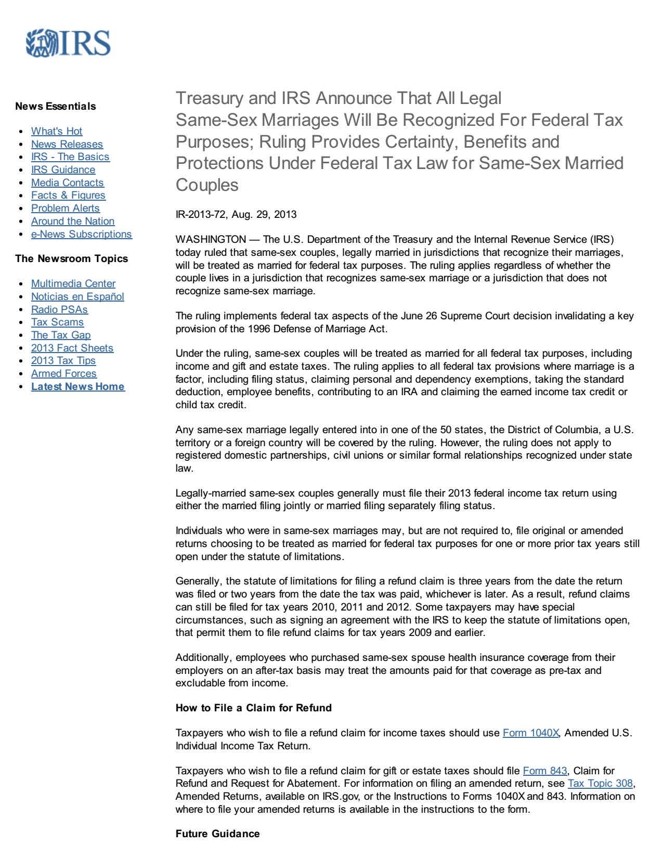

Rev. Rul. 2013-17

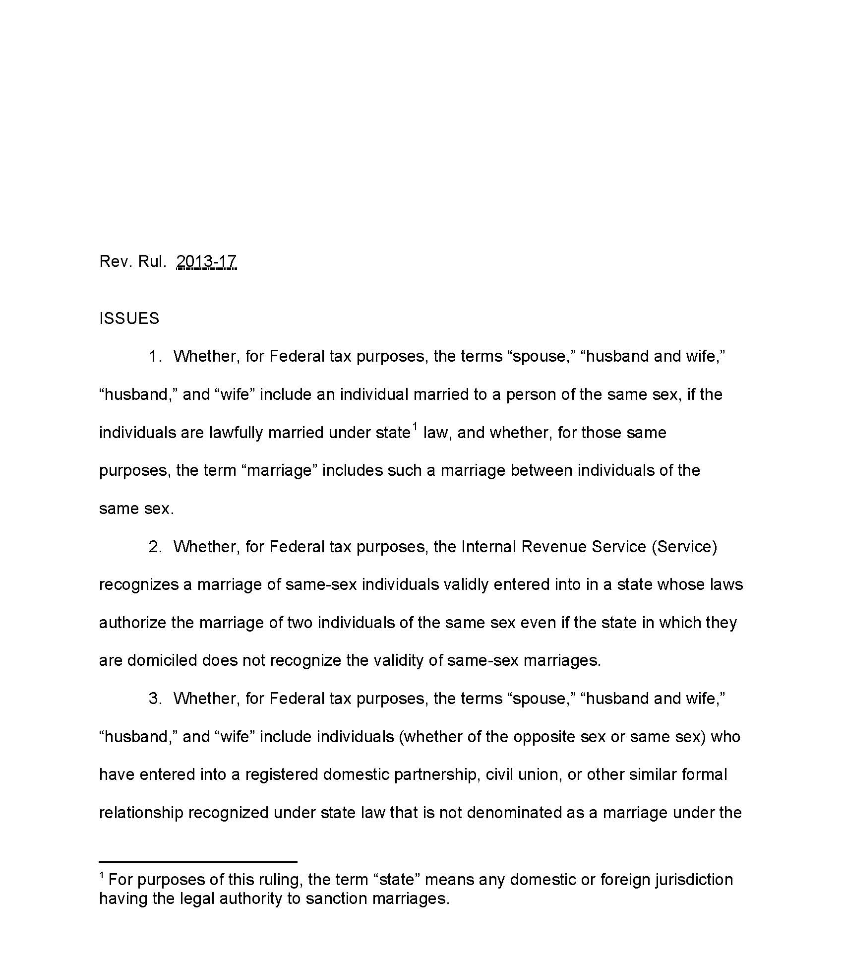

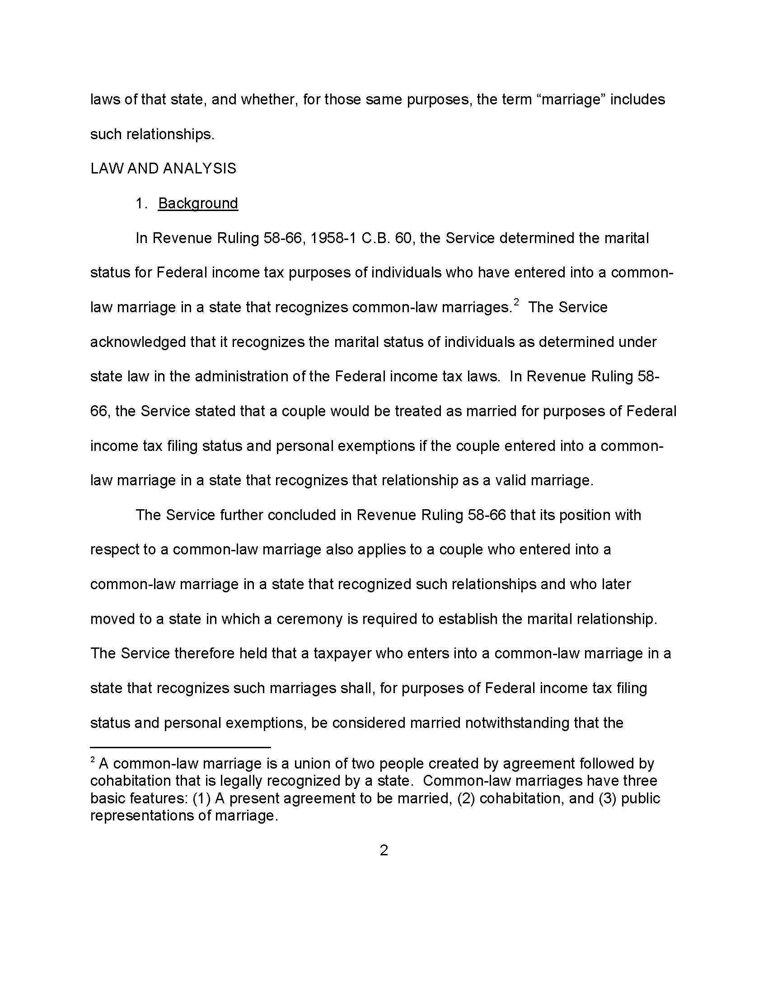

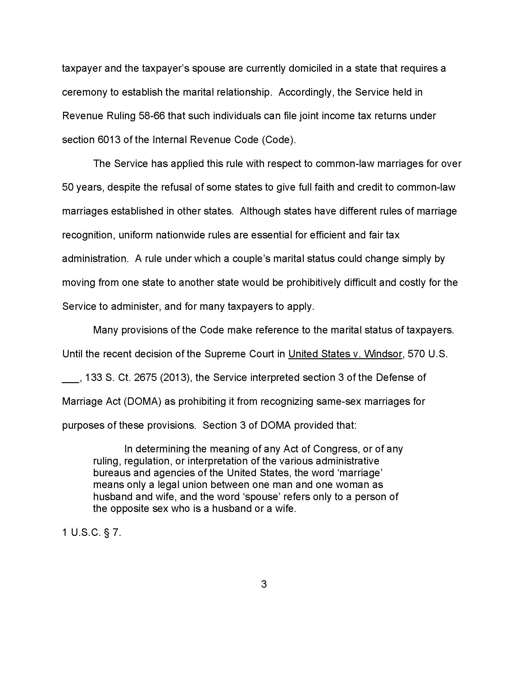

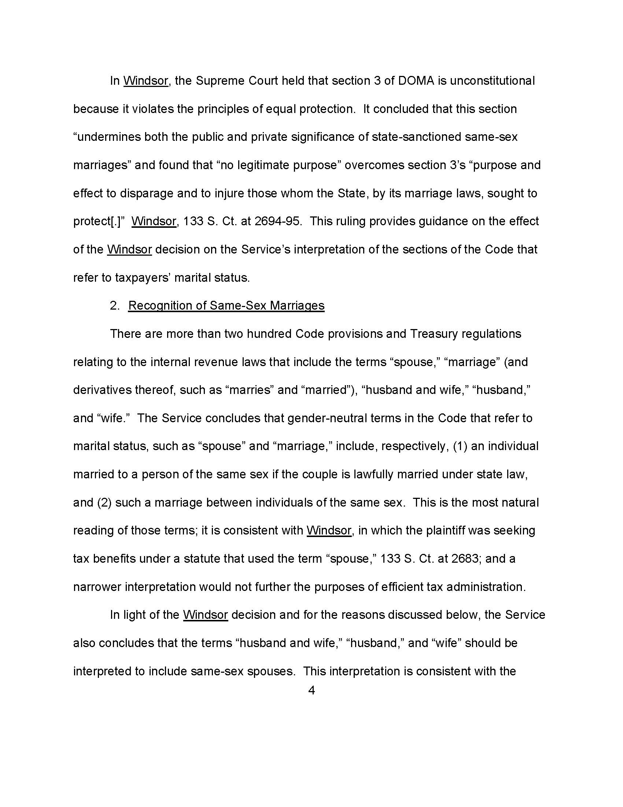

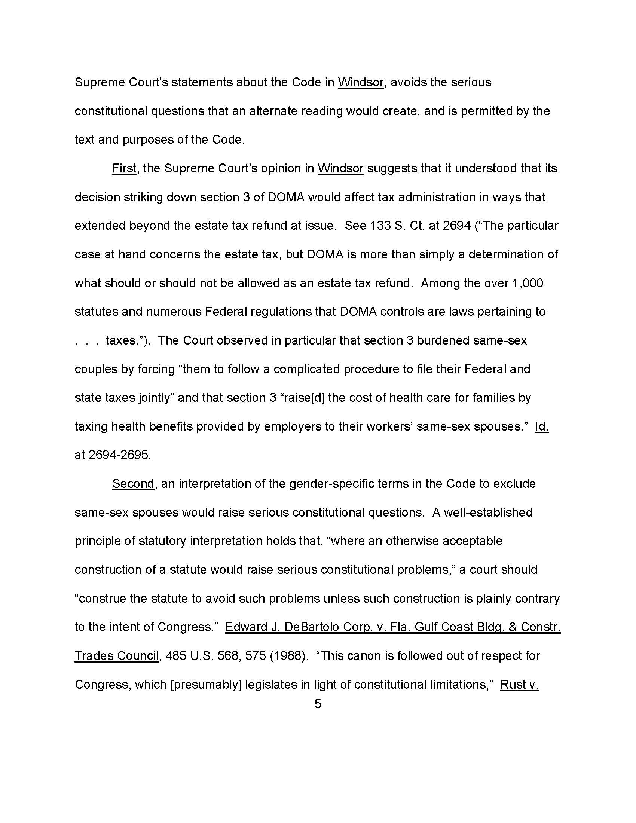

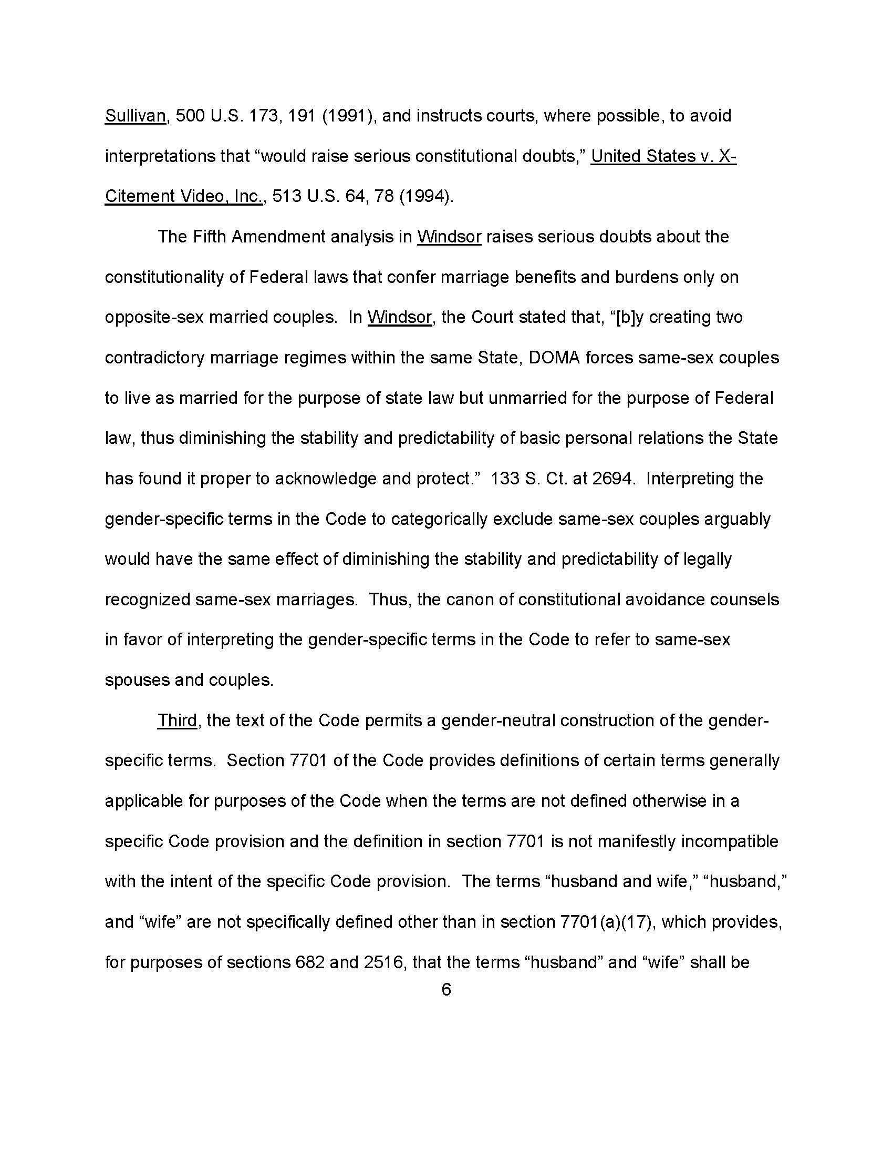

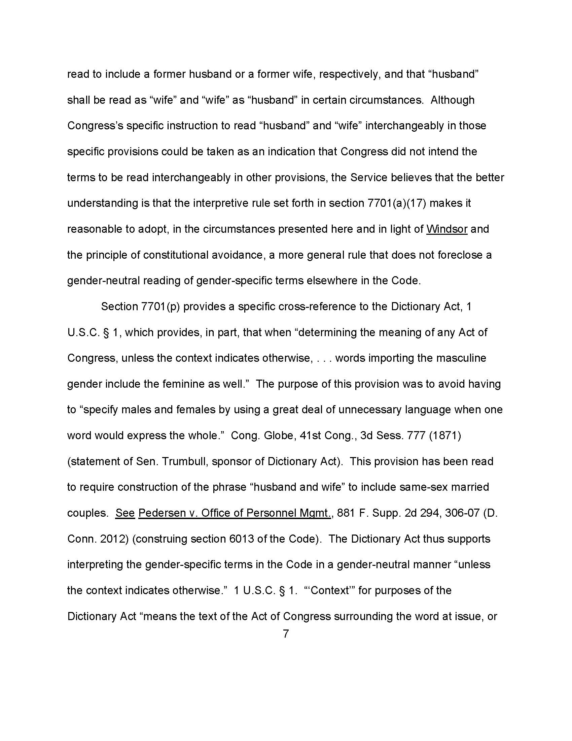

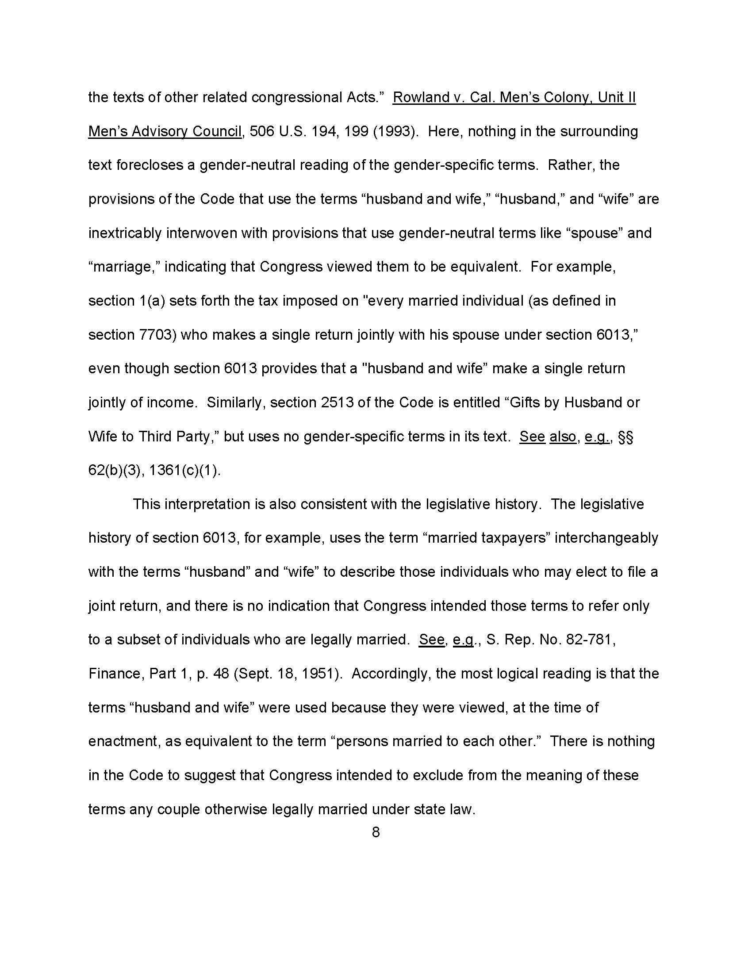

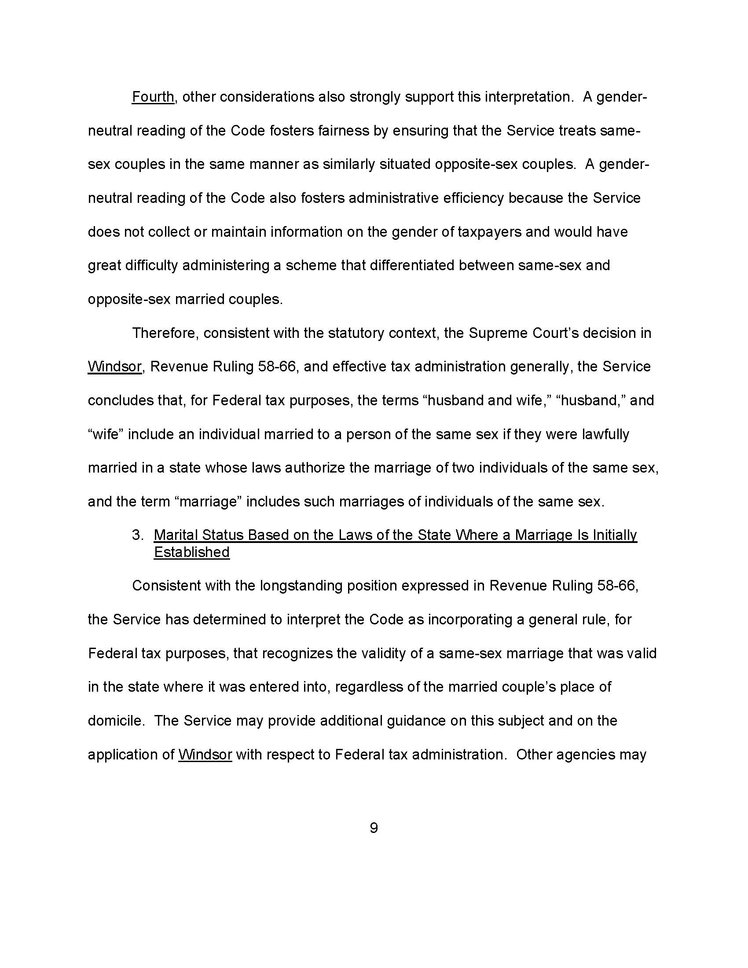

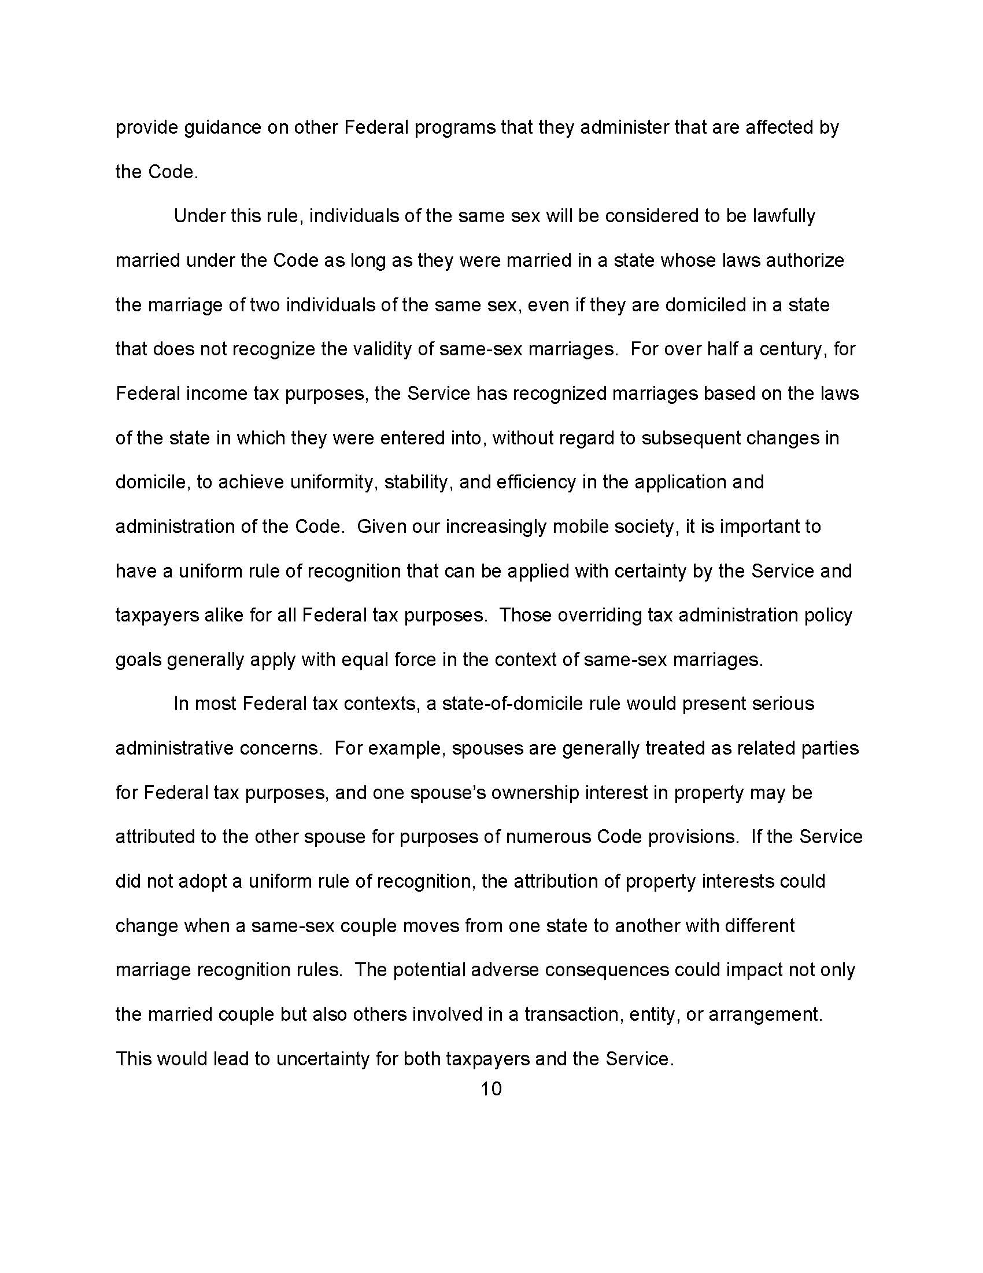

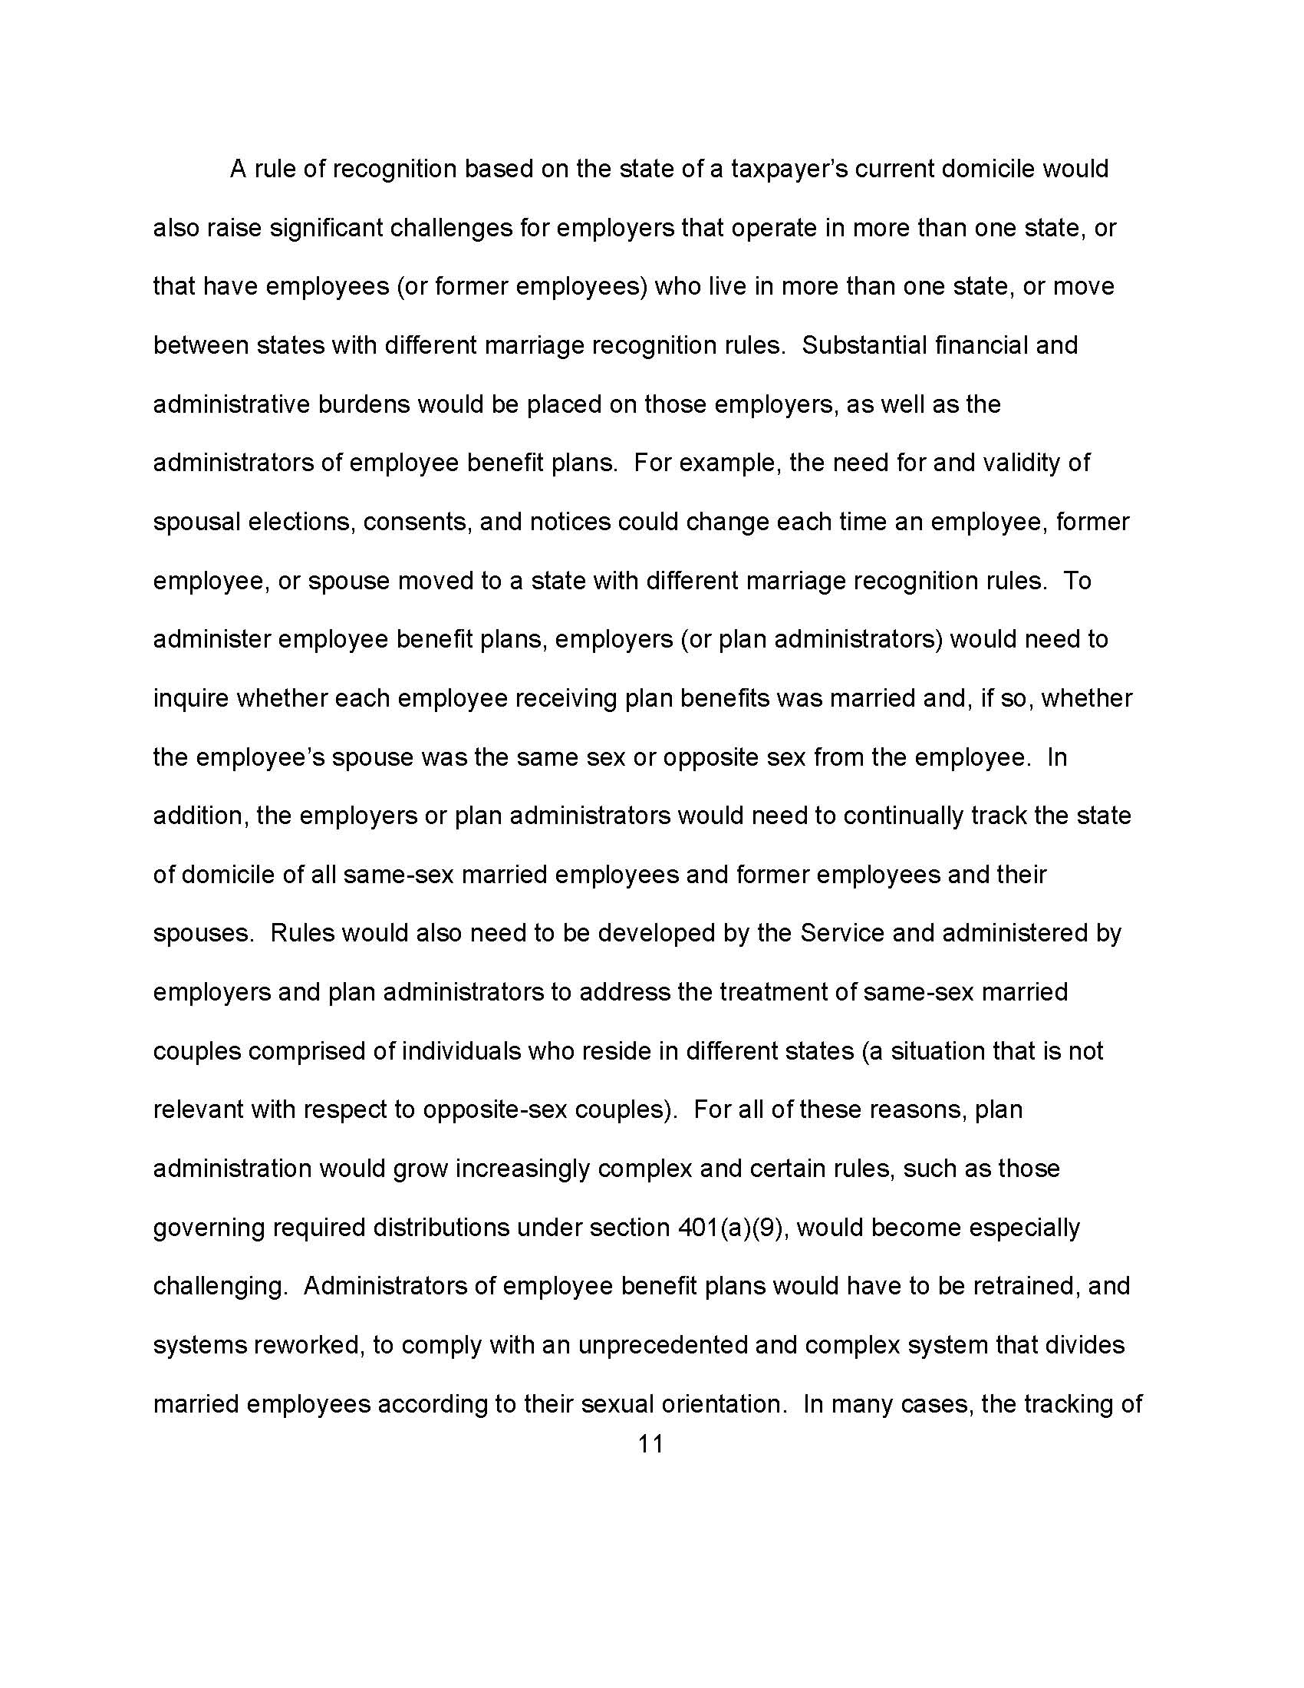

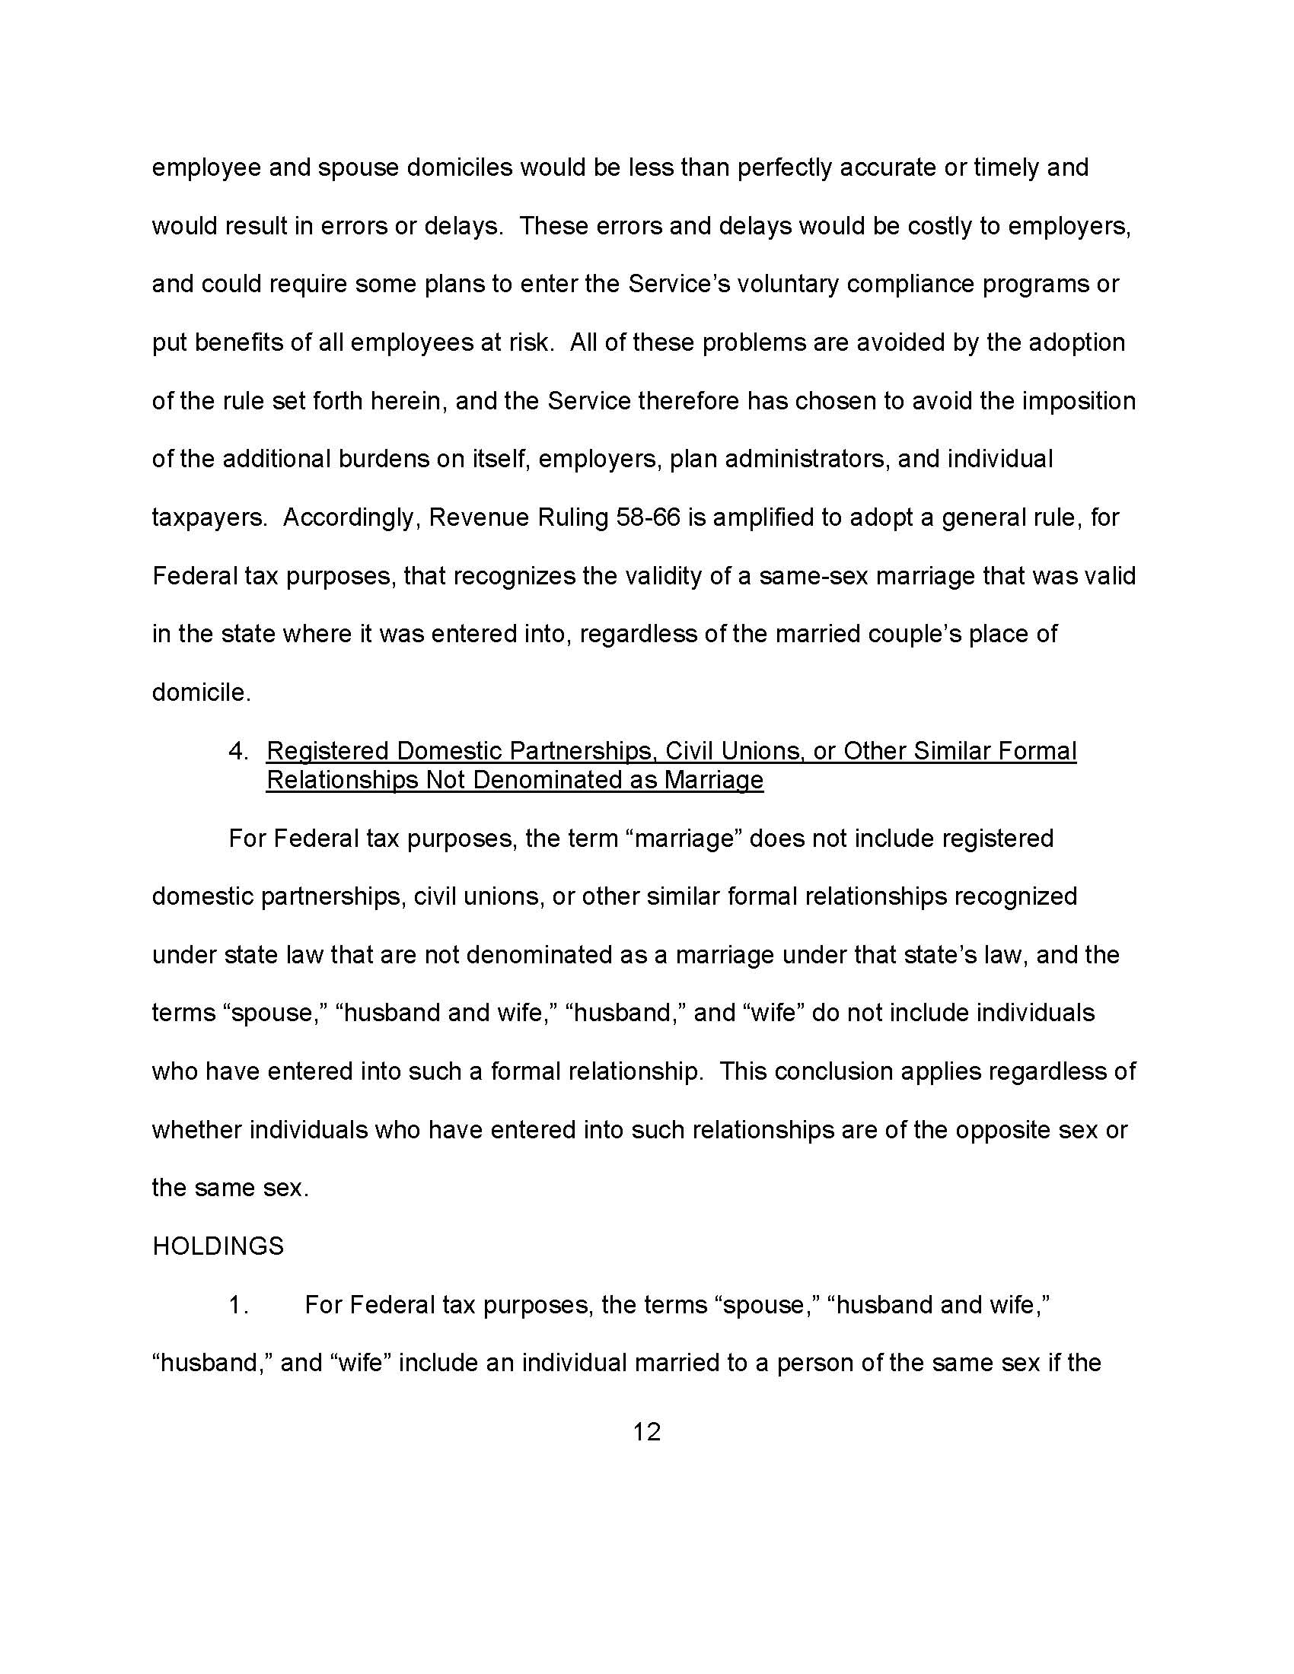

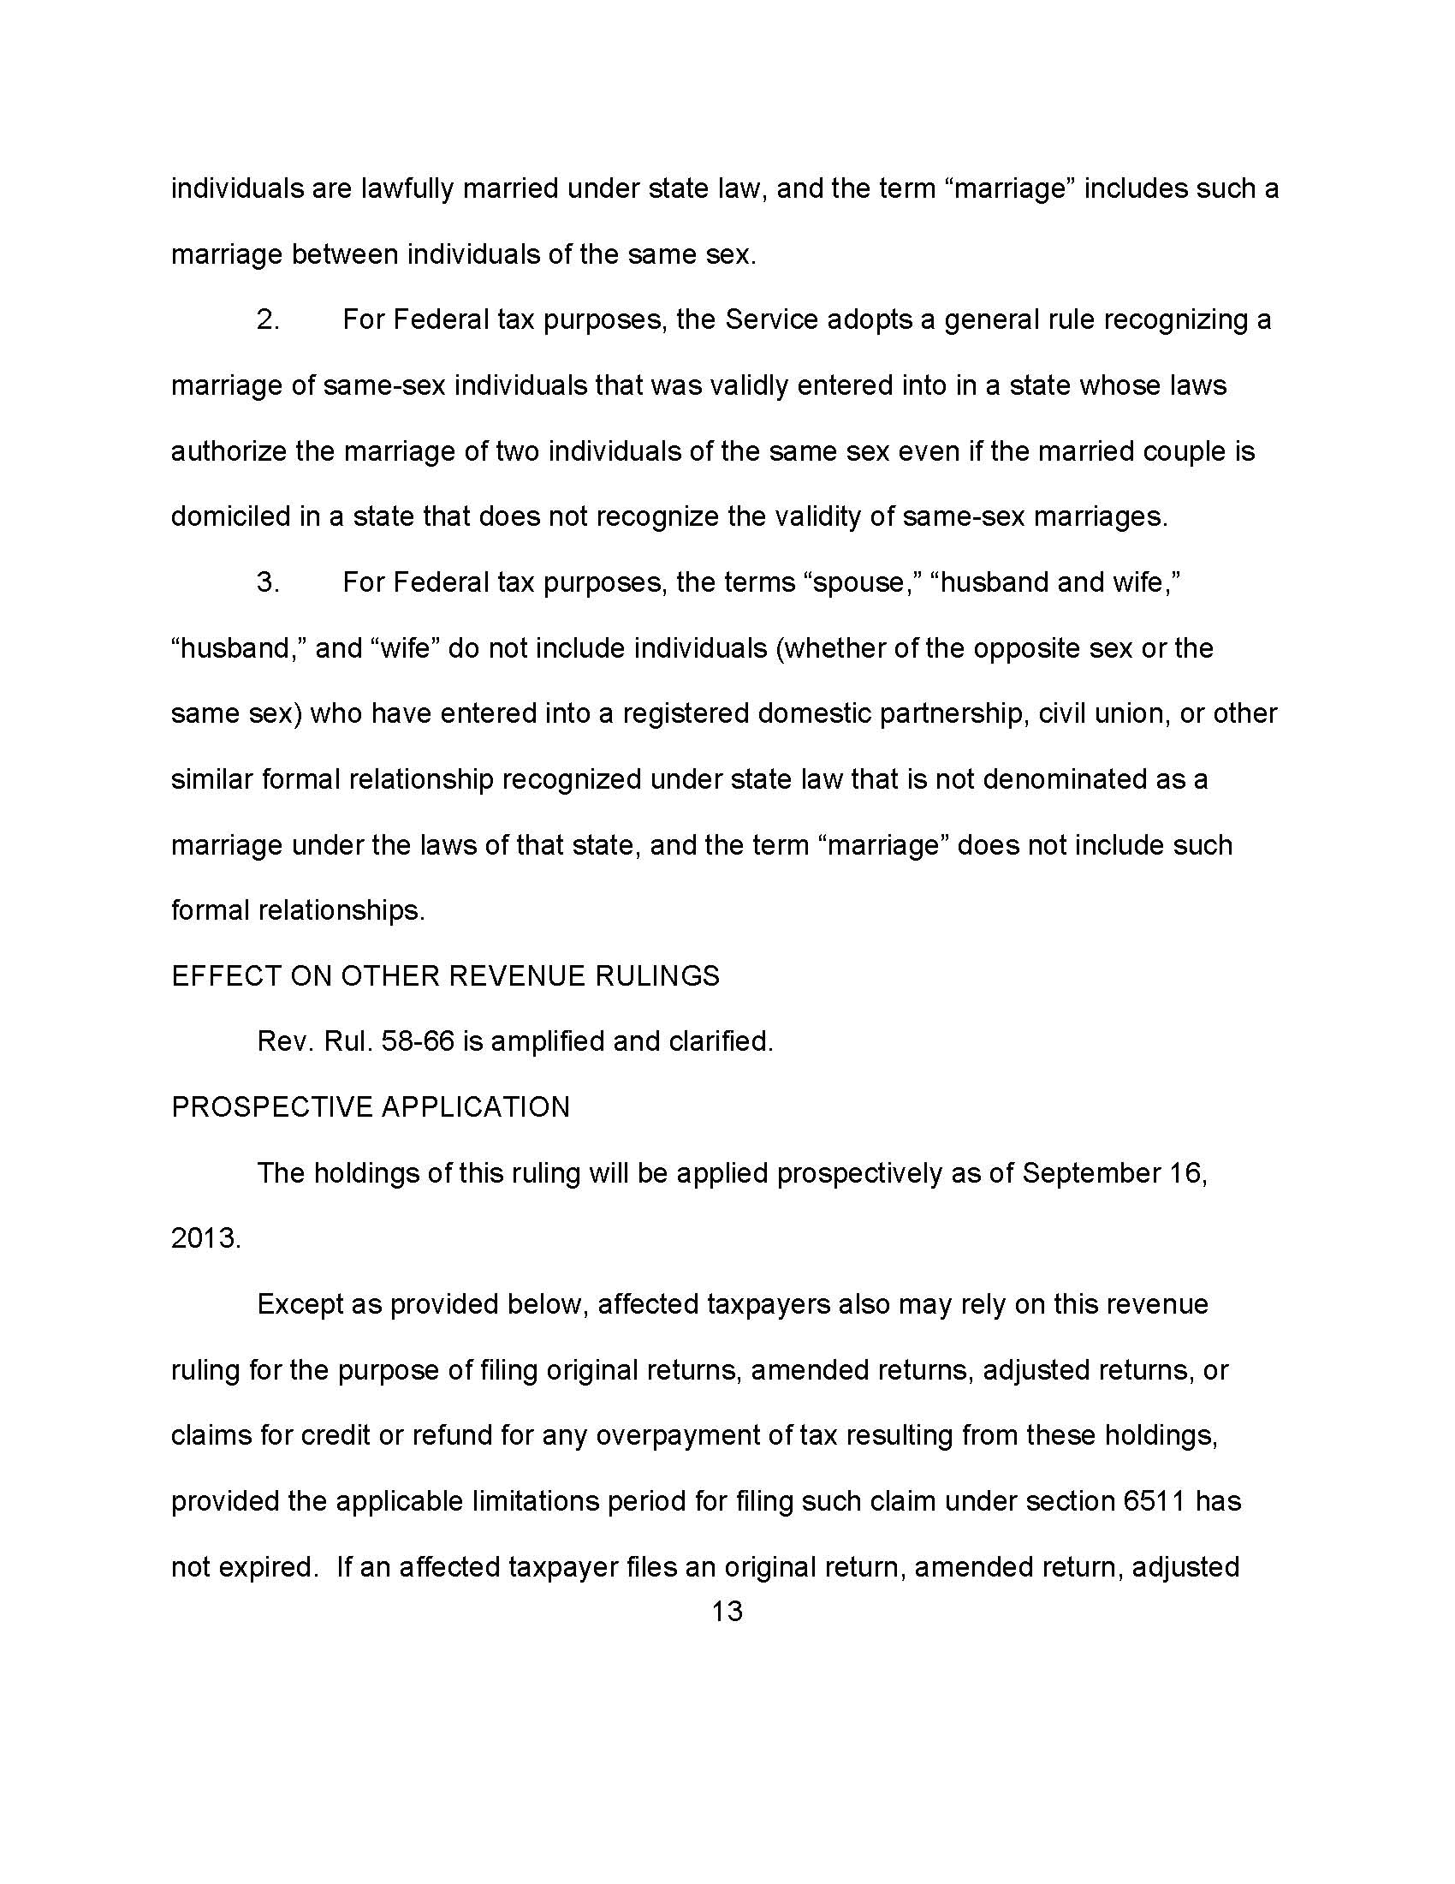

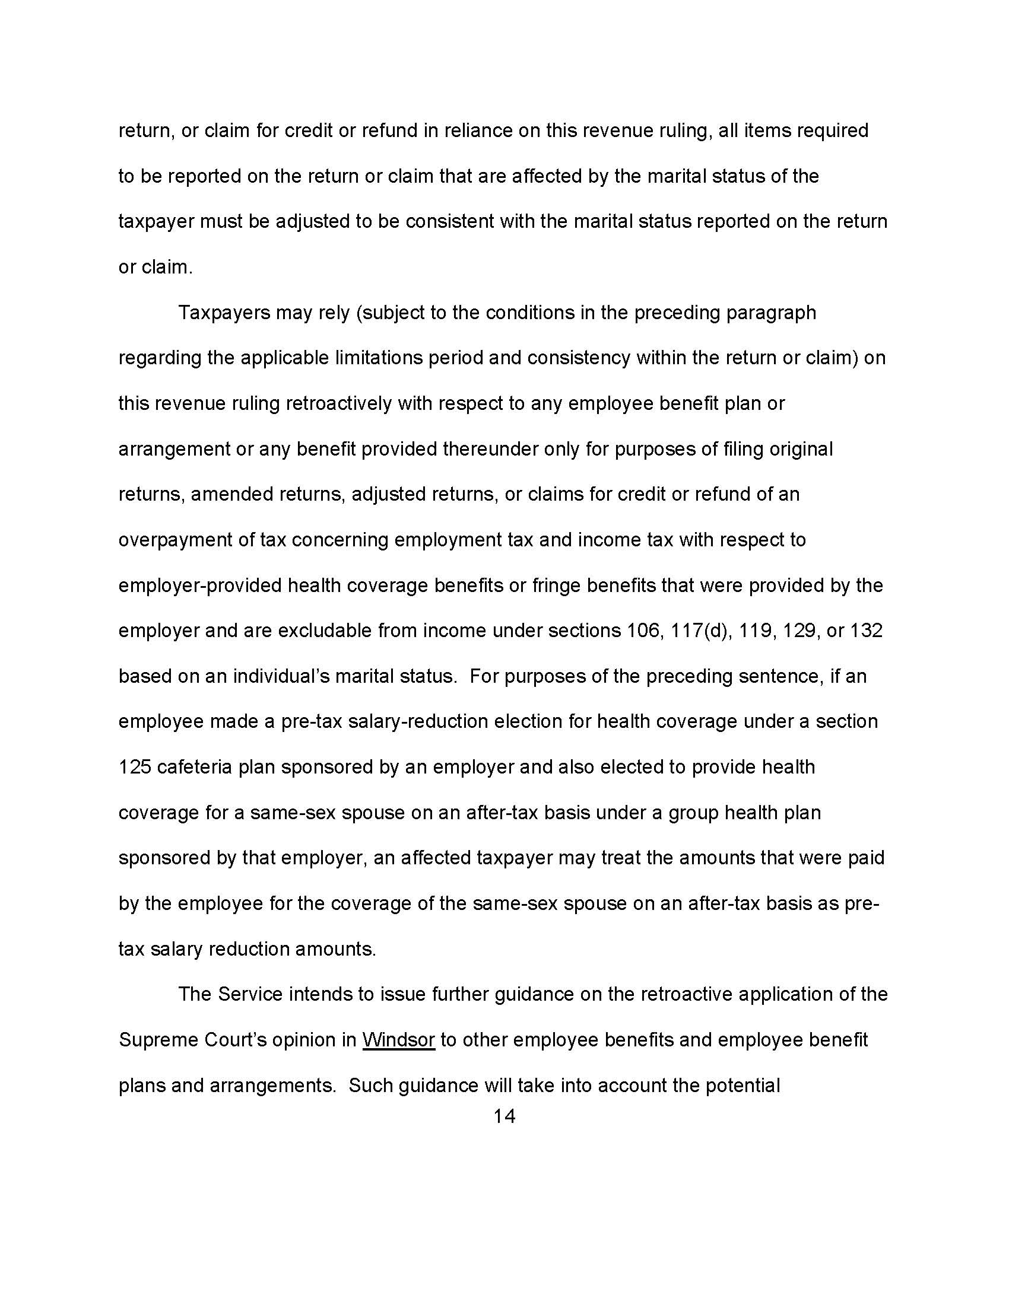

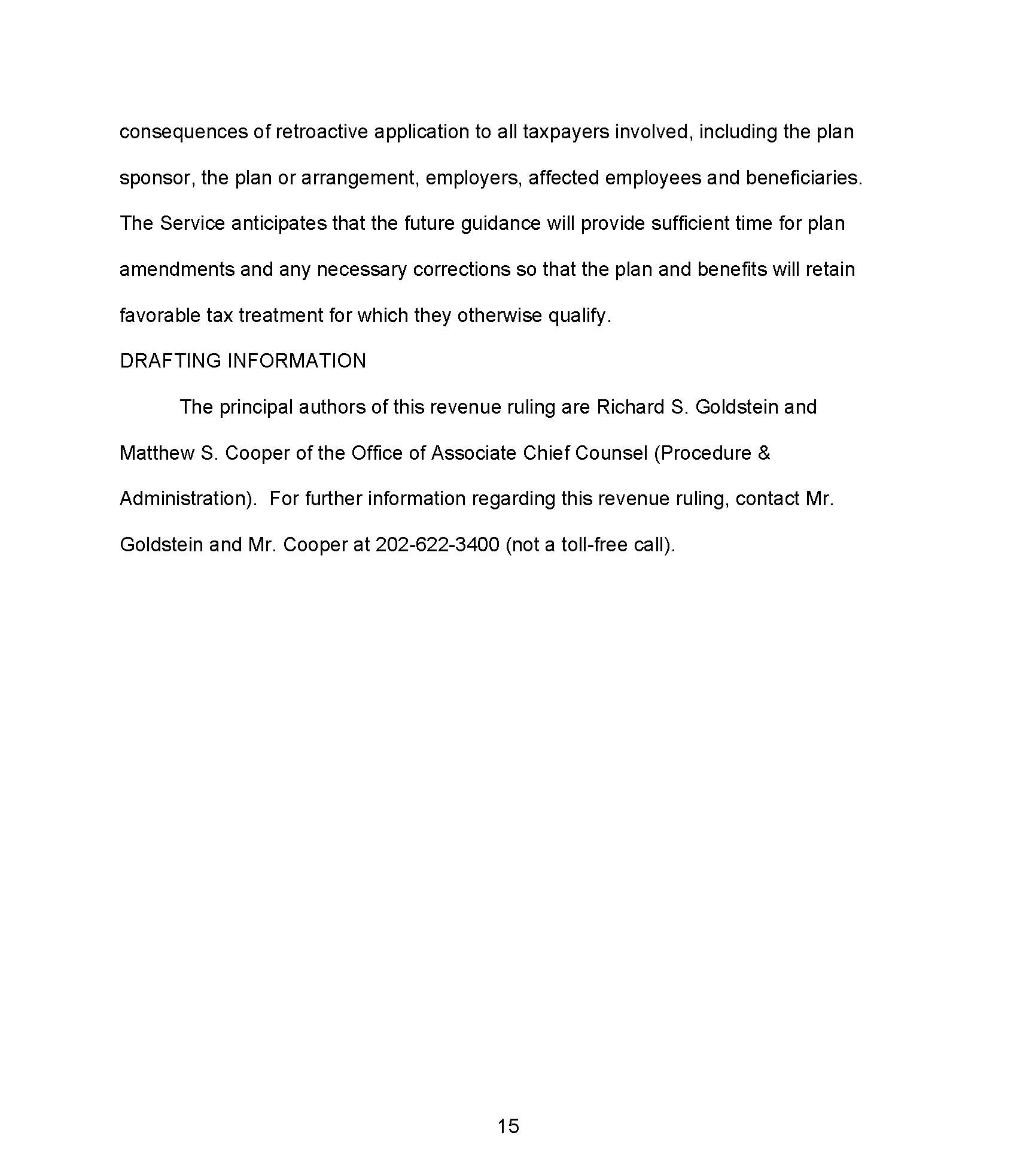

Projected Unified Credit Increases

Cumulative Additional Unified Credit Assuming
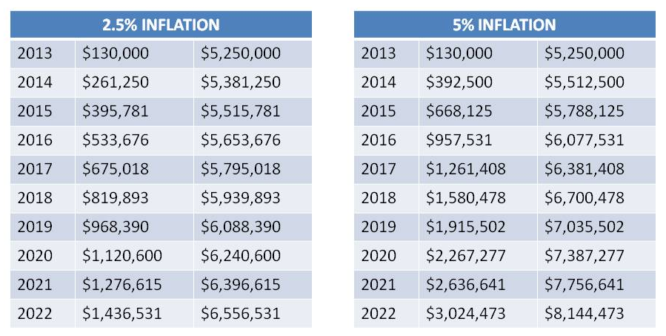

GRAT

Two Year GRAT deemed to earn 1.4%
(pursuant to Code Section 7520)
(assuming created in July 2013)
Upon the creation of this GRAT, there is no gift-tax, but there is a small amount being passed to the remainder beneficiaries.

Two Year GRAT earning 10%
Upon the creation of this GRAT, there is also no gift tax, yet, there is $137,914 being passed to the remainder beneficiaries.

Two Year GRAT earning 30%
Upon the creation of this GRAT, there is also no gift tax, yet, there is $ 515,811 being passed to the remainder beneficiaries.

GRAT

The GRAT Rush of 2013
Short Term GRAT Planning May be Prohibited

The House of Representatives legislation, if enacted, would eliminate the low-risk short-term grantor retained annuity trust or GRAT. It would require a duration of 10 years for GRATs

Before law is enacted, there is a window of opportunity to tap into the huge gift-tax savings now associated with GRATs

NOTE: Sale to a Grantor Trust is another great alternative tax technique that could also be significantly curtailed if sales to grantor trusts would no longer be disregarded if between the trust settlor and the grantor trust.

GRAT

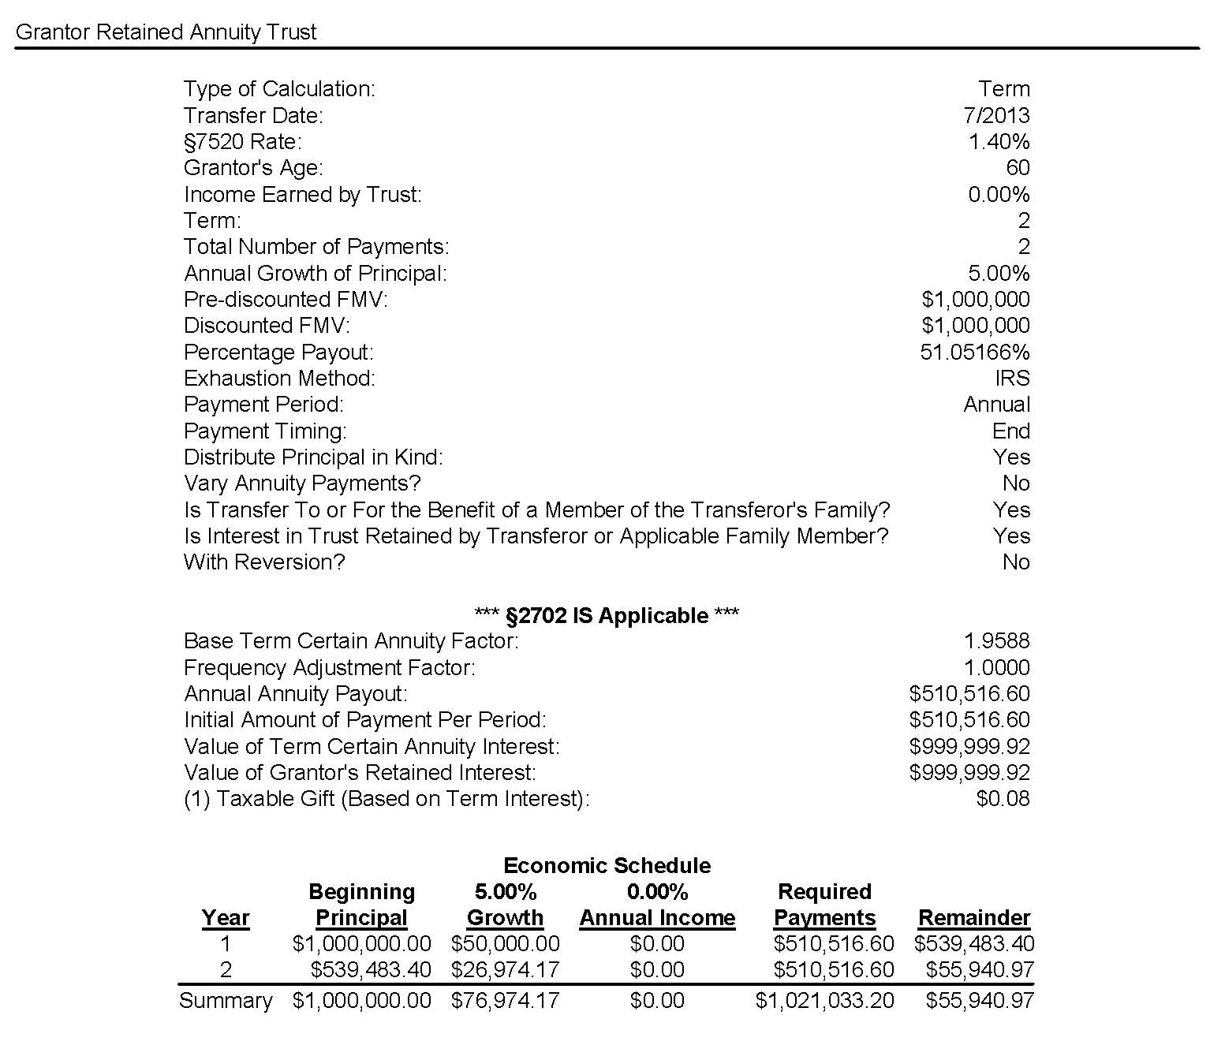

Prepared using Steve Leimberg’s Number Cruncher software.

GRAT

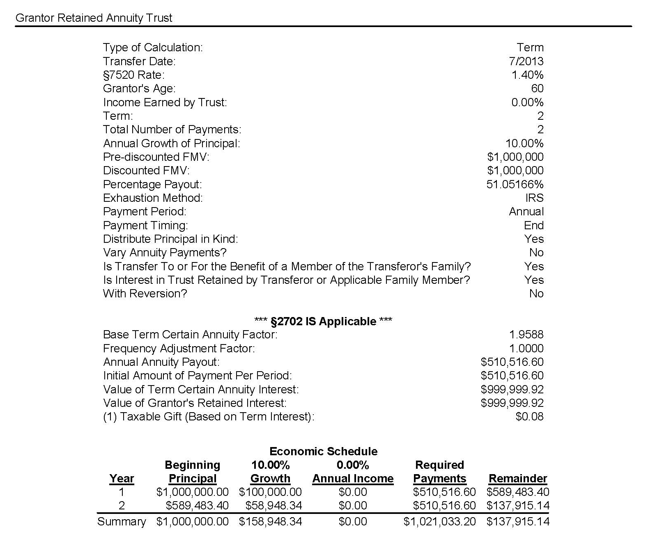
Prepared using Steve Leimberg’s Number Cruncher software.

GRAT

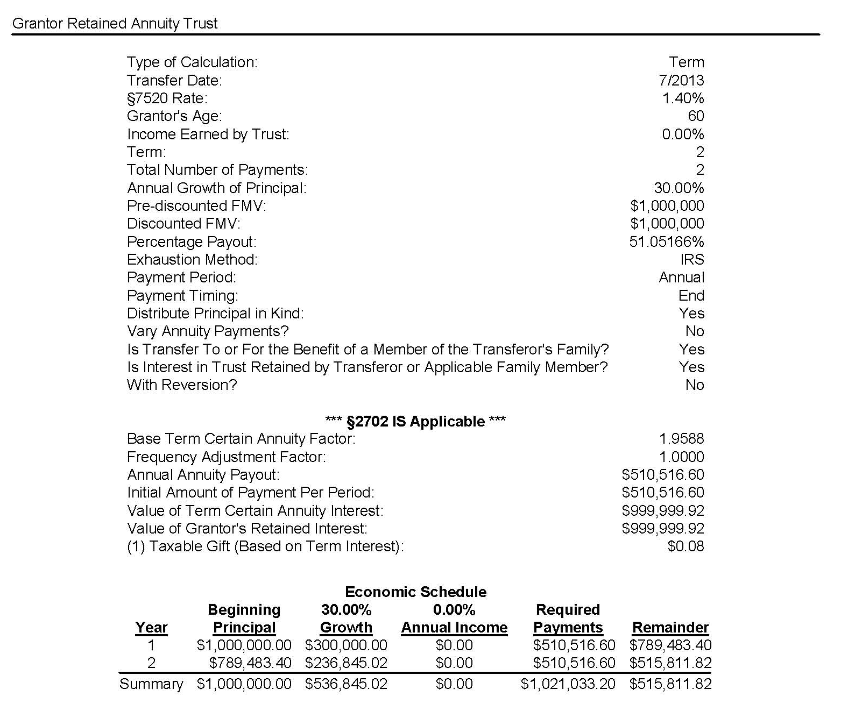
Prepared using Steve Leimberg’s Number Cruncher software.

Advantage of Lifetime Gift of Unified Credit to Shift Future Appreciation
$5.25 Million Exemption

- Compounding:
  - You make a $5 M gift this year
  - You die 20 years from now
  - The value of that gift will be:

7520 Interest Rates & AFRs OCT 1989-2012

Applicable Federal Mid-Term 120% Annual Rates

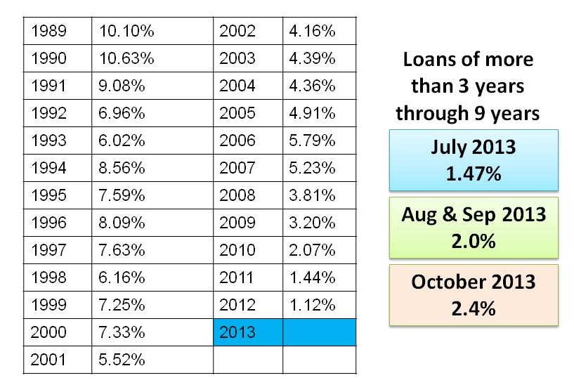

7520 Rates From 1989 to 2013

Section 7520 Rates
 | Jan. | Feb. | Mar. | Apr. | May | Jun. | Jul. | Aug. | Sep. | Oct. | Nov. | Dec.
1989 |  |  |  |  | 11.6% | 11.2% | 10.6% | 10.0% | 9.6% | 10.2% | 10.0% | 9.8%
1990 | 9.6% | 9.8% | 10.2% | 10.6% | 10.6% | 11.0% | 10.6% | 10.4% | 10.2% | 10.6% | 10.6% | 10.2%
1991 | 9.8% | 9.6% | 9.4% | 9.6% | 9.6% | 9.6% | 9.6% | 9.8% | 9.6% | 9.0% | 8.6% | 8.4%
1992 | 8.2% | 7.6% | 8.0% | 8.4% | 8.6% | 8.4% | 8.2% | 7.8% | 7.2% | 7.0% | 6.8% | 7.4%
1993 | 7.6% | 7.6% | 7.0% | 6.6% | 6.6% | 6.4% | 6.6% | 6.4% | 6.4% | 6.0% | 6.0% | 6.2%
1994 | 6.4% | 6.4% | 6.4% | 7.0% | 7.8% | 8.4% | 8.2% | 8.4% | 8.4% | 8.6% | 9.0% | 9.4%
1995 | 9.6% | 9.6% | 9.4% | 8.8% | 8.6% | 8.2% | 7.6% | 7.2% | 7.6% | 7.6% | 7.4% | 7.2%
1996 | 6.8% | 6.8% | 6.6% | 7.0% | 7.6% | 8.0% | 8.2% | 8.2% | 8.0% | 8.0% | 8.0% | 7.6%
1997 | 7.4% | 7.6% | 7.8% | 7.8% | 8.2% | 8.2% | 8.0% | 7.6% | 7.6% | 7.6% | 7.4% | 7.2%
1998 | 7.2% | 6.8% | 6.8% | 6.8% | 6.8% | 7.0% | 6.8% | 6.8% | 6.6% | 6.2% | 5.4% | 5.4%
1999 | 5.6% | 5.6% | 5.8% | 6.4% | 6.2% | 6.4% | 7.0% | 7.2% | 7.2% | 7.2% | 7.4% | 7.4%
2000 | 7.4% | 8.0% | 8.2% | 8.0% | 7.8% | 8.0% | 8.0% | 7.6% | 7.6% | 7.4% | 7.2% | 7.0%
2001 | 6.8% | 6.2% | 6.2% | 6.0% | 5.8% | 6.0% | 6.2% | 6.0% | 5.8% | 5.6% | 5.0% | 4.8%
2002 | 5.4% | 5.6% | 5.4% | 5.6% | 6.0% | 5.8% | 5.6% | 5.2% | 4.6% | 4.2% | 3.6% | 4.0%
2003 | 4.2% | 4.0% | 3.8% | 3.6% | 3.8% | 3.6% | 3.0% | 3.2% | 4.2% | 4.4% | 4.0% | 4.2%
2004 | 4.2% | 4.2% | 4.0% | 3.8% | 3.8% | 4.6% | 5.0% | 4.8% | 4.6% | 4.4% | 4.2% | 4.2%
2005 | 4.6% | 4.6% | 4.6% | 5.0% | 5.2% | 4.8% | 4.6% | 4.8% | 5.0% | 5.0% | 5.0% | 5.4%
2006 | 5.4% | 5.2% | 5.4% | 5.6% | 5.8% | 6.0% | 6.0% | 6.2% | 6.0% | 5.8% | 5.6% | 5.8%
2007 | 5.6% | 5.6% | 5.8% | 5.6% | 5.6% | 5.6% | 6.0% | 6.2% | 5.8% | 5.2% | 5.2% | 5.0%
2008 | 4.4% | 4.2% | 3.6% | 3.4% | 3.2% | 3.8% | 4.2% | 4.2% | 4.2% | 3.8% | 3.6% | 3.4%
2009 | 2.4% | 2.0% | 2.4% | 2.6% | 2.4% | 2.8% | 3.4% | 3.4% | 3.4% | 3.2% | 3.2% | 3.2%
2010 | 3.0% | 3.4% | 3.2% | 3.2% | 3.4% | 3.2% | 2.8% | 2.6% | 2.4% | 2.0% | 2.0% | 1.8%
2011 | 2.4% | 2.8% | 3.0% | 3.0% | 3.0% | 2.8% | 2.4% | 2.2% | 2.0% | 1.4% | 1.4% | 1.6%
2012 | 1.4% | 1.4% | 1.4% | 1.4% | 1.6% | 1.2% | 1.2% | 1.0% | 1.0% | 1.2% | 1.0% | 1.2%
2013 | 1.0% | 1.2% | 1.4% | 1.4% | 1.2% | 1.2% | 1.4% | 2.0%

7520 Rates From 1989 to 2013

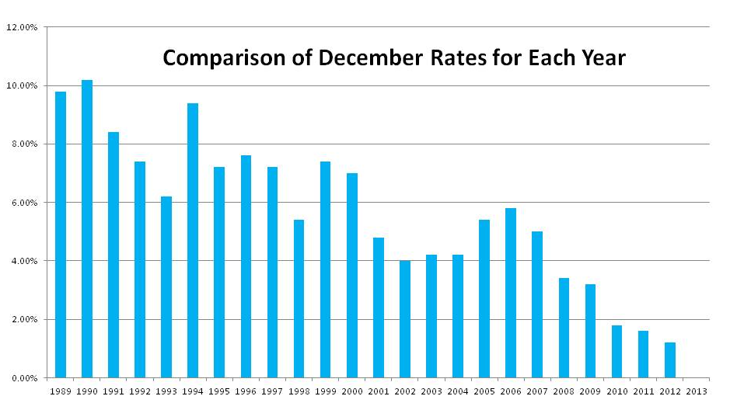

Intra-Family Loans and AFRs

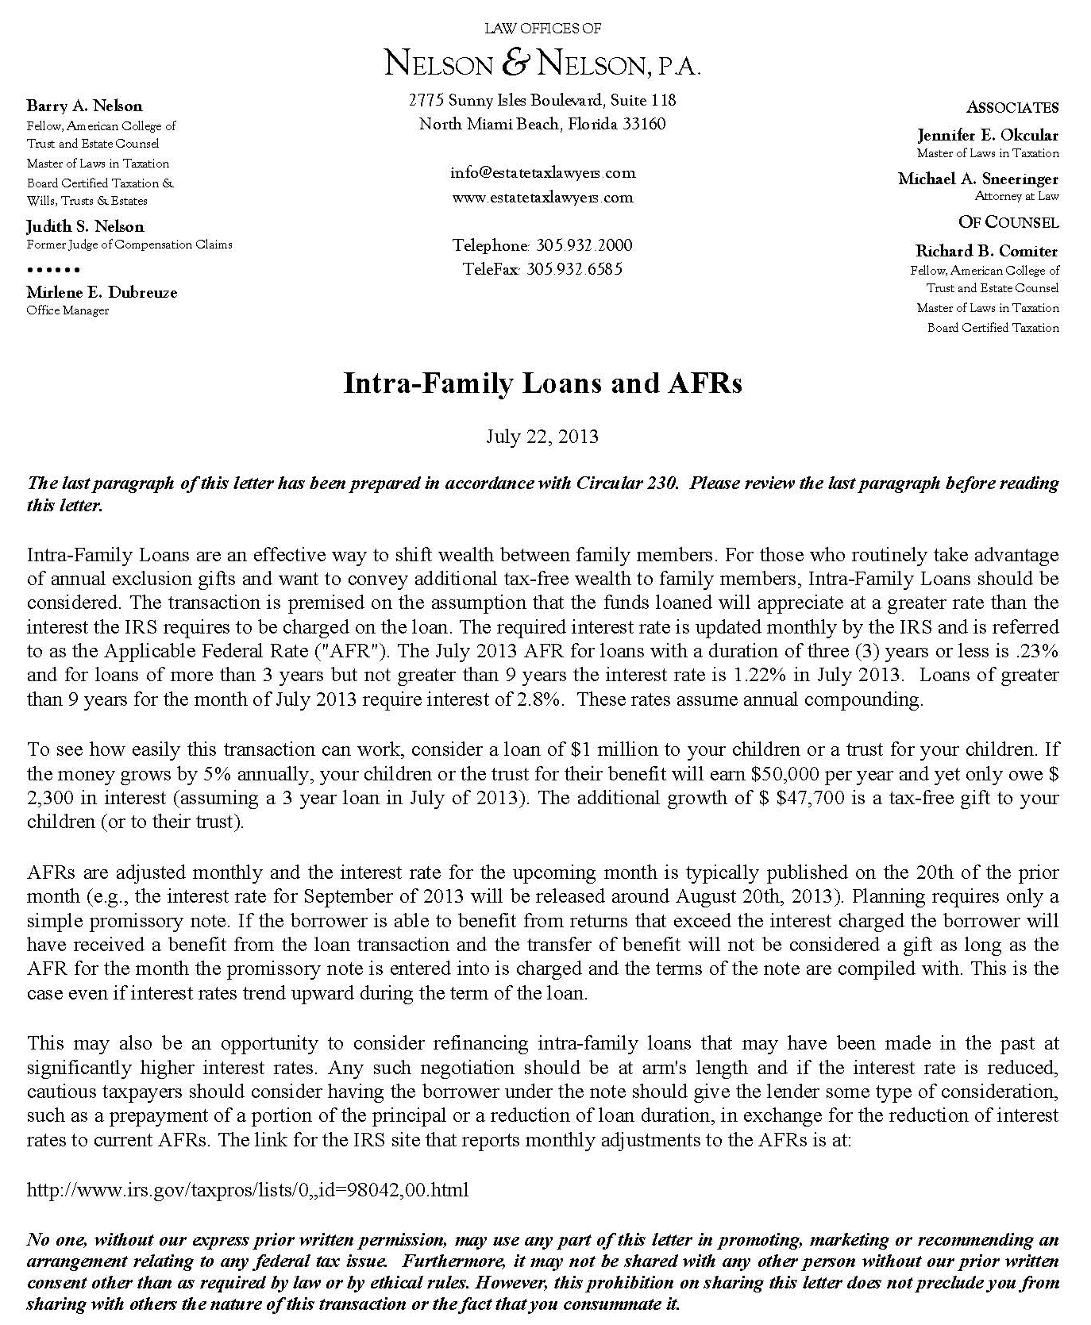

Intra-Family Loans and AFRs

July 2013
Example:
- Consider a loan of $1 M to your children or their trust
- If the money grows by 5% annually, your children or their trust will earn $50,000 per year and only owe $2,300 in interest (assuming a 3 year loan in July 2013)
- The additional growth of $47,700 is a tax-free gift to your children or their trust

August 2013
Section 7520 Rate is 2.0%

Intra-Family Loans and AFRs - July 2013

Intra-Family Loans and AFRs - August 2013

Are Trust Funds Safe From Claims for Alimony or Child Support?
by Barry A. Nelson
as published in Trusts & Estates Magazine, April 2013

LINK TO ARTICLE

New §736.0505(3) Assures Tax/Asset Protection of Inter Vivos QTIP Trusts
by Barry A. Nelson
as published in The Florida Bar Journal, December 2010

LINK TO ARTICLE

CITE AS:
LISI Estate Planning Newsletter #2149 (September 30, 2013) at http://www.LeimbergServices.com © 2013 Law Offices of Nelson & Nelson, P.A. Reproduction in Any Form or Forwarding to Any Person Prohibited – Without Express Permission.

